Force Analysis of Car Crash and Potential Improvements

Michael Li (Yunze), Mike Yan (Yi)

The Peddie School, NJ

Sep. 2020 - Mar. 2021

**Abstract**

Since the world entered the 21st century, technology, notably in the automobile industry, has experienced innovation and refinement at an incredible pace. However, as more advanced vehicle models are produced, people now direct their attention to the safety measure of automobiles. Making the protective structure, especially the bumper, safer yet lighter is now a dominant demand in the market. According to researchers, the most frequent type of collision that happens in the past is frontal collision, in which the bumper plays a crucial role at reducing the impact force to protect the driver and the passengers. This paper focuses on the analysis of a typical SUV frontal collision with a stationary obstacle. The simulation is based on the European New Car Assessment Programme (E-NCAP), standards in the automobile industry, and a simplified finite element model of a car.

This paper investigates whether substituting the aluminum alloy bumper with carbon fiber composite bumper will improve its performance, specifically including bumper’s peak impact force (F), bumper intrusion (L), force absorption by the bumper (Q), upward displacement of the steering column hole (S1), backward displacement of the steering column hole (S2), the mass of the bumper (m), etc. After comparing and analyzing the substitution, it was discovered that although the performance improved, it is subtle. Notably, the mass of the bumper decreased by 43.19% after the substitution. However, the S1 value still exceeds E-NCAP standard, which is where future study should focus on.

Though the performance of the substituted bumper did not improve significantly, the mass is lowered by a considerable percentage. This study can be used to support future experiments about minimizing the mass of other parts of an automobile while subtly improving its performance at the same time.

**CONTENT**

1. Introduction 4

1.1. Background and Significance 4

1.2. Introduction to Automobile Collision and Safety Regulations 9

1.3. Current Studies 11

2. Finite Element Analysis (FEA) 13

2.1. FEA Analysis 13

2.2 Analytic Method of FEA 14

2.2.1 Current FEA Softwares: HyperWorks 16

2.2.2 Current FEA Softwares: LS-DYNA 16

2.3 Basic Theory Behind FEA 17

2.3.1 FEA Model in Collision Analysis 18

2.3.2 Explicit FEA Integration 20

2.3.3 Constitutive model of Elastoplastic material 20

2.4 Basic Mechanics Theory of Composite Materials 22

2.4.1 Introduction of Composite Materials 22

2.4.2 Main Structure of Composite Materials 23

2.4.3 Orthotropic Material Mechanics Model 26

2.4.4 Strength and Failure Criteria of Composite Materials 28

3. Analysis of 100% Frontal Car Crash Simulation 33

3.1 Building 100% Frontal Car Crash Model with FEA 33

3.1.1 Simplifying Vehicle Model 33

3.1.2 Finite Element Meshing 35

3.1.3 Defining Material and Properties 36

3.1.4 Time Step Control 37

3.1.5 Controlling Hourglass 38

3.1.6 Model Connection Settings 38

3.1.7 Contact Settings 39

3.2 Analysing Result from Simulation 40

3.2.1 Analysing Image Sequence During Collision 40

3.2.2 Energy Change 43

3.2.3 Increase in Mass 44

3.2.4 Analysis of Impact Force of Bumper Collision 44

3.2.5 Bumper Deformation 45

3.2.6 Bumper Energy Absorption Analysis 46

3.2.7 Upward Displacement of Steering Column Hole 47

3.2.8 Backward Displacement of the Steering Column Hole 48

3.3 Building Model with Composite Materials 49

3.3.1 Equivalent design for Front Bumper Beam 49

3.3.2 Establishment of Finite Element Model of Composite Bumper 51

3.3.3 Graph of Total Energy in the Composite bumper model. 52

3.3.4 Comparison and Analysis of Collision Response Indexes of Two Kinds of Material Bumpers 52

4. Conclusion 57

5 Reference 58

# 1. Introduction

## 1.1. Background and Significance

Since the turn of the 21st century, the car industry has witnessed unprecedented growth. Car production has been skyrocketing on a global scale. In only 2 decades, car production almost doubled compared to the start of the 21st century, which already reached a height of 56 million (figure 1). The demand for automobiles grew from year to year and bounced to an even higher level after the stimulation of the 2008 economic crisis. Because of the steadily increasing demand, automobile quality becomes a major topic of discussion by customers; safety is the most important facet considered by consumers. From smart airbags to auto-cruise, and from lane departure warning to automatic brakes, technologies that aim to promote safety have been central to the automobile market.

Figure 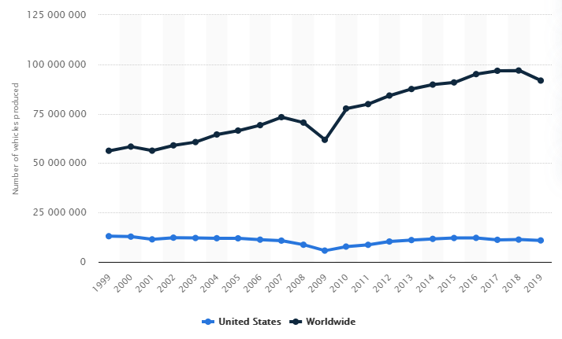1 Vehicle production in the US and worldwide

Automobile safety is categorized into two types: *active safety* and *passive safety*. Active safety function refers to the automobile traveling in accordance with the driver’s spontaneous intent when the driver is steering and that the car is able to remain steady during both linear brake and acceleration and turning direction; it should also minimize the potential of accidents and achieve maximal safety, all without interfering with the driver’s vision comfortability. On the other hand, passive safety refers to the structure within the frame of the automobile, including the metallic structure, airbags, and devices optimizing their performance, that can minimize damage to the driver and passengers after the accident has taken place.

Even though the safety precautions nowadays are more advanced than ever, car accidents still could not be avoided. In New Jersey specifically, the number of car crashes stayed level at around 270 thousand cases every year, according to the data collected since 2001, causing an average of over 60000 deaths per year. Of all car accidents, approximately 23% are *side impact collisions*, 6% are *rear collisions*, about 14% are *rollovers*, and over half of the accidents are *frontal collisions*. Most importantly, the death rate of frontal impacts is much higher than that of other types of collisions, regardless of car types. Therefore, envisioning a safer design of cars’ structure that would minimize the impacts of frontal collisions is of primal importance.

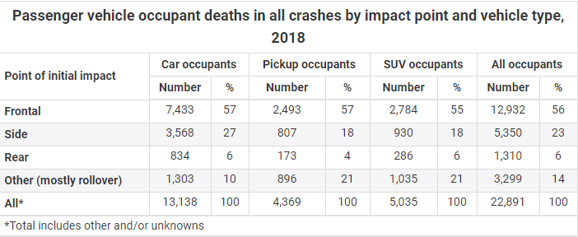

Figure 2 Passenger vehicle occupant deaths in all crashes by impact point and vehicle type, 2018

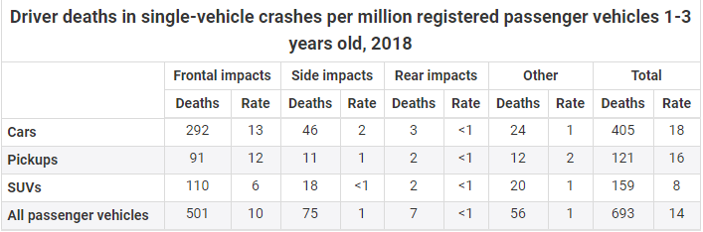

Figure 3 Driver deaths in single-vehicle crashes per million registered passenger vehicles 1-3 years old, 2018

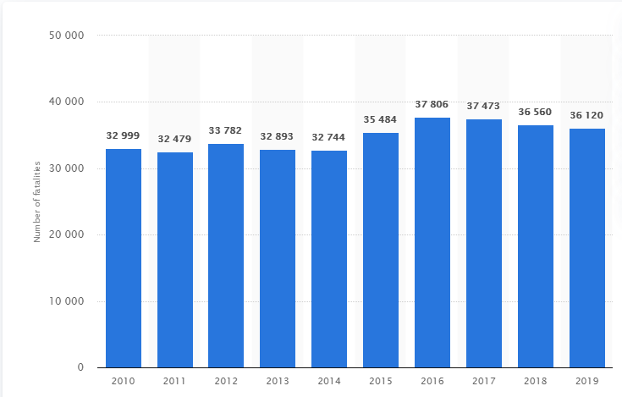

Figure 4 Number of fatalities in the US per year

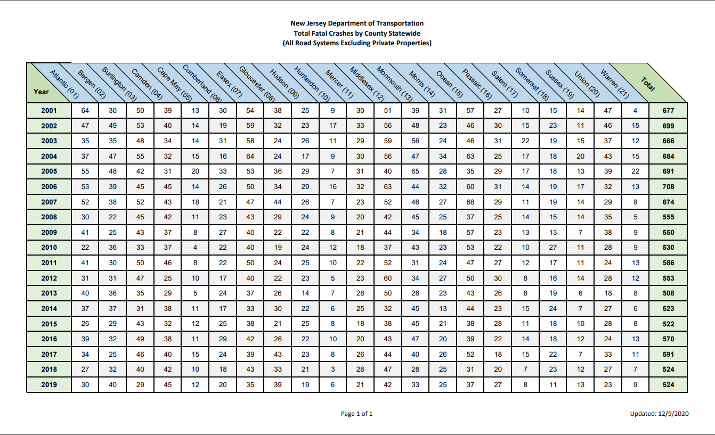

Figure 5 Total fatal crashed in New Jersey

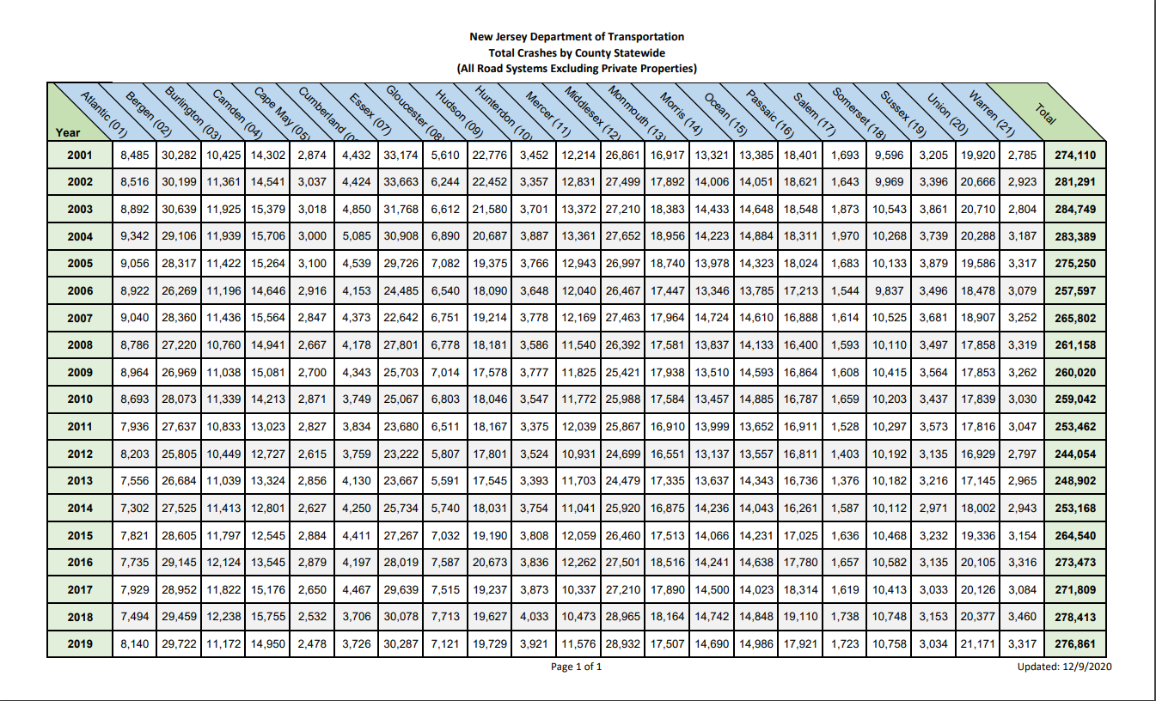

Figure 6 Total crashes in New Jersey

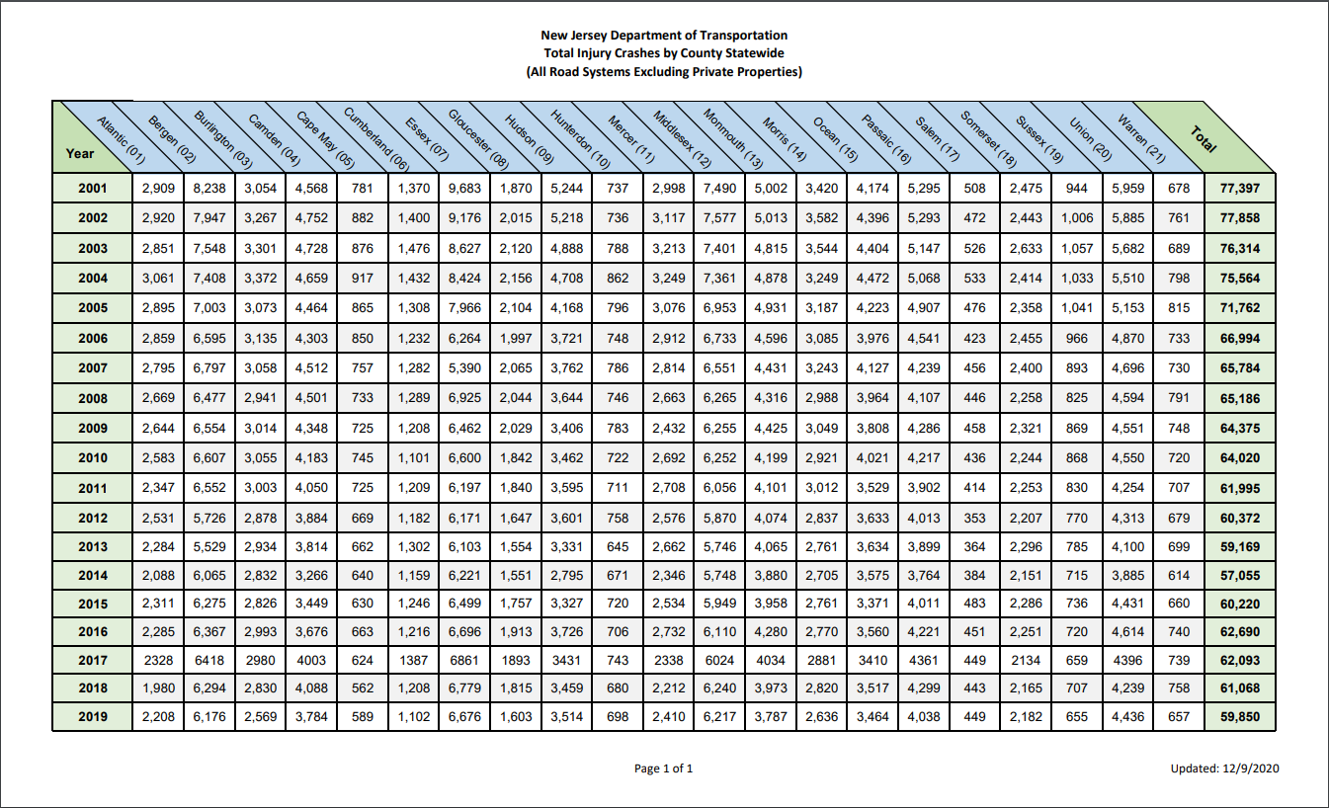

Figure 7 Total injury crashes in New Jersey

## 1.2 Introduction of Automobile Collision and Safety Regulations

The issue of automobile safety has always been closely watched by government agencies, major automobile manufacturers, and consumers. The emergence of automobile safety regulations adds a powerful reference standard to the evaluation of vehicle crash tests and quality inspections. At the legal level, it is a mandatory constraint imposed by government departments on manufacturers; at the product design level, it provides effective guidance for developers; and at the product safety level, it is an important guarantee for consumers. From the earliest integration of passive safety and active safety in car driving to ensuring the safety of drivers, and at the same time paying attention to the reduction of casualties in the event of a collision, the formulation of safety regulations is generally valued by various countries and people, and various road conditions. The collection of data has been continuously completed, as various collision experiments have been continuously strengthened.

At present, the formulation of real-vehicle crash test regulatory systems by countries around the world is mainly reflected in the two major systems of European regulations and the American motor vehicle safety standard FMVSS. With the continuous development of safety regulations and the continuous response to the call of automobile safety performance, other continents or countries have referred to their actual vehicle crash test regulations and have also begun to formulate independent automobile regulations that meet their national conditions. They continued to move towards standardization and globalization. There are three main types of real vehicle test collisions in these two systems: (a) 100% frontal overlap rate rigid fixed barrier impact test, (b) 40% frontal overlap rate offset deformable barrier impact test, (c) oblique angle barrier Impact test.

(1) The European Road Traffic Safety Commission’s legal system can effectively take into account safety regulations (such as active safety, passive safety, general safety) and energy conservation based on the special environment in which it is located. Such as pollution control, energy conservation and environmental protection, and other energy aspects) implemented regulations, and can be effectively adapted to European countries. Commonly used crash safety standards are: (a) E-NCAP (Euro-New Car Assessment Program, European New Car Assessment Program) "Frontal Collision Regulations"; (b) E-NCAP "Side Impact Regulations"; (c) E-NCAP "Pedestrian Protection Test Methods" and so on.

(2) The U.S. collision regulations have basically formed a complete system, such as occupant collision protection, side collision occupant protection, fuel system integrity, electric vehicle safety requirements, etc., which are quite complete and are still developing and Update. Commonly used crash safety standards are: (a) FMVSS (Federal Motor Vehicle Safe Standard) American motor vehicle safety standards; (b) US-NCAP (US-New Car Assessment Program) American new car crash standards; (c) IIHS-NCAP (Insurance Institute for Highway Safety- NCAP) United States Highway Safety Insurance Association-New Car Collision Standards, etc.

Throughout this experiment, we are using the E-NCAP standards because it has wider applications in multiples parts of the world and is specifically advantageous in its focus on active safety, passive safety, and general safety.

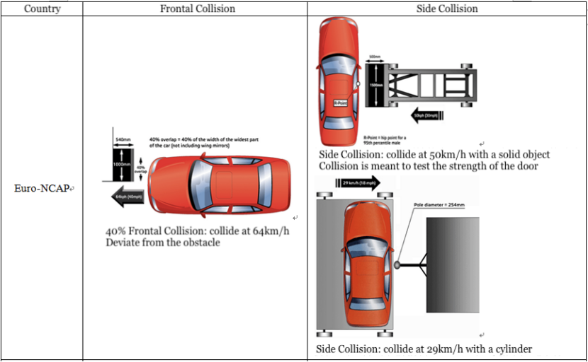

Figure 8 E-NCAP

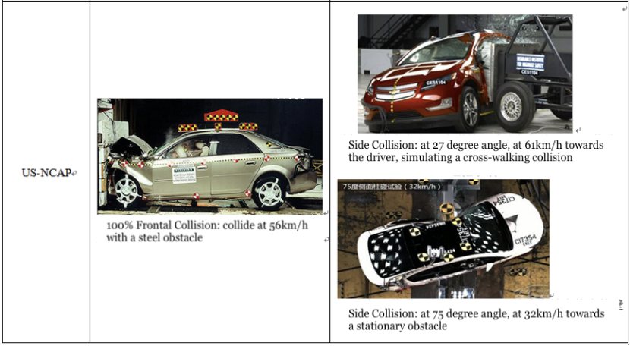

Figure 9 US-NCAP

## 1.3 Current Studies

Research on automobile passive safety began in the 1930s. Preliminary research was conducted using an empirical approach. Experiments included real car collisions and simulated collisions. The experimental results are valuable for refining the structural design of automobiles in order to improve their passive safety function. Car collision experiments help obtain data such as deformation under force during a collision, utilize these data to verify the safety index of a car’s components upon impacts, and predict the degree of the car’s collisional damage. However, with the development of the automobile industry, the number of car components increased, and force analysis became more complex. As a result, experimental errors are more frequent, requirements for the accuracy of measuring instruments are higher, and experiments are generally more expensive and time-consuming.

To resolve the drawbacks of real car collision experiments, engineers have begun applying mathematical and mechanical computations and algorithms into passive safety research. Through simplified simulation of major car components and the use of spring and damping units, which connect the simplified components, engineers could acquire analytical solutions that reflect collision-characteristic index via methods of force and mathematical analysis.

As computers gained popularity around the 1960s, their computational power was utilized to build models of vehicles for crash analysis. However, due to the technological restraints, it is only limited to solving analytical equations from the collisions, which is still time-consuming and inaccurate. As computers evolve, more complex models and calculations can be made to achieve a more realistic result. Not only did the efficiency improve, but the accuracy also reached an unprecedented level, allowing the development of Multibody Dynamic Theory. Although the calculation is complicated by this advancement, the results from the crash analysis can finally be used in real-life scenarios.

As the computer hardware developed, related software followed the path. Under positive feedback and stimulation from the market, more software emerged and soon matured. Software like Hypermesh, a product from Altair Engineering, build the basis for force and dynamic analysis that were impossible to achieve half a century ago. Now, in the 21st century, algorithms regarding safety are not merely a mathematical theory anymore. It becomes a tool that aids the optimization of vehicle structure development, passenger protection, and human biomechanics.

# 2. Finite Element Analysis (FEA)

## 2.1. FEA Analysis

Finite Element Analysis, abbreviated as FEA, is the origin of the development of CAE (computer-aided engineering) technology and a major constituent in CAE technical application. Whether it is force analysis on automobile structure or experiments and verification, FEA has become a tool widely used. Also, FEA has shaped the latest design methodology for automobiles, which comprises design, computation, experiment, and optimization.

Automobile collision is an instantaneous, intricate non-linear process, and it is associated with various fields of study -- material nonlinearity, contact tribology, structural deformation, elastoplastic theory, plate and shell theory, and etc. The process of analyzing data is often extremely complex and requires large-scale computations. Consequently, effectively conducting simulation analysis on the body in white collisions and thus reducing physical experiments is of chief importance. Through FEA, with mathematical theories as a foundation and with methods of discretization, we are able to transform the nonlinear computations into linear problems so that solutions could be achieved. Applying mechanics theories and using variational principle, FEA can divide a body in white into a finite collection of small unit elements. We can use slice interpolation to express force distribution, connect finite elemental nodes, describe the mechanical properties of each element with the index data, and finally establish the overall mechanical properties and features of the entire body in white model. Its dynamic differential equation is:

MU’’+CU’+KU = F

In the equation, M is the mass matrix; C is the damping matrix; K is the stiffness matrix; F is the external force vector; U is the displacement vector.

In finite elements, a continuous body can be divided into a two-dimensional continuous body and a three-dimensional continuous body, as shown by the pictures below. Picture 1 illustrates a 2-D plane continuous body that has undergone meshing; its major components are quadrilateral and triangular elements. Picture 2 illustrates a 3-D spatial continuous body that has undergone meshing; its major components are tetrahedral and hexahedral elements. The linkage between these small elements helps transmit information for finding a solution. A finite number of different elements composes a continuous body; moreover, one can discretize infinite continuous bodies into finite unit bodies to analyze and find solutions.

Steps in FEA analytical research usually include structural discretization, unit analysis, and global solution. General FEA process has three parts: model preprocessing, analytical computation and finding solutions, and postprocessing. For instance, a seat frame’s FEA preprocessing is importing a finished CAD model into a HyperMesh software and carrying out a series of tasks -- geometric cleaning, meshing, node connection, unit mass control, etc. After HyperMesh completes preprocessing, we can import the processed frame model into LS-DYNA solver for analysis and computations. Post Processing is carried out by importing raw data from the solver into HyperView and HyperGraph for detailed analysis.

## 2.2 Analytic Method of FEA

The automobile crash test is a short and continuous process of transient changes. During this process, some parts will undergo obvious deformation, produce large displacements, experience tension, and are compressed by dynamic forces. Therefore, they can be converted into a geometric nonlinear problem.

With the development of computers and the growing integration of mathematics, mechanics, and computers, the finite element method since the 1950s has continuously gained attention and is widely used on this basis. It is one of the indispensable tools that engineers and universities use to solve practical problems.

The basic idea of finite element is to decompose the entire continuous solution area or structure first, and discretely form finite small areas or units with different sizes and shapes. Then the adjacent areas are connected in a specific way, as shown in diagram (a); then, the force change conditions of each area or unit are given, as shown in diagram (b); next, discretized model based on the finite element is constructed, as shown in diagram (c); finally, the approximate value of the entire area is solved according to the boundary conditions. If the process is convergent, the result is closer to the exact value, as diagram (d) shows. In the entire solution process, the complexity of solving practical problems will be greatly simplified, and it significantly improves the work efficiency of engineers and scholars. The finite element analysis process is shown in Figure 10.

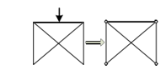 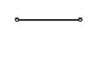

(a) Decomposition of regional structure (b) Analysis of each unit

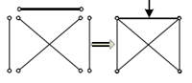 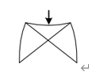

(c) Model building (d) Problem solving

Figure 10 Finite Element Analysis process

### 2.2.1 Current FEA Softwares: HyperWorks

HyperWorks is an FEA software developed by Altair Engineering Inc. It is capable of modifying and organizing finite element models imported from CAD, a format that is well-established in the current engineering industry. With the aid of built-in modules like HyperMesh, HyperView, and HyperGraph, HyperWorks is able to generate accurate predictions and calculations based on the model.

HyperMesh is the preprocessor that is responsible for generating a finite element model for the imported file. It is able to process exceptionally fast, and the results are flexible to change in variables. Its allowance for multiple import file types makes it a suitable software choice in many different situations as well. Moreover, there are no limits to model sizes, which makes HyperWorks ideal for large projects like car crash analysis. HyperMesh also possesses a simple yet clear UI design that is favorable to new learners.

HyperView is the post-processor for multibody dynamics. It delivers interactive data sets and graphs to the user through the simple user interface, making results more comprehensible.

HyperGraph is the graphing utility that aids HyperView and HyperWorks. It can generate accurate graphs within a short time span. What’s more, it accepts a wide variety of file formats.

### 2.2.2 Current FEA Softwares: LS-DYNA

LS-DYNA is the most well-known force and motion analyzing software. It is capable of replicating real-life problems into the software, and it simplifies the scenario by analyzing it with Math and Physics. It is very ideal for solving 2D or 3D non-linear problems related to high-speed collisions and explosions. It is also an ideal tool when facing problems related to heat transfers, fluids and fluid-structure interaction. LS-DYNA is the most widely used software by the current industry, and its accuracy and reliability is proven by numerous experiments and practices.

LY-DYNA’s popularity is a result of its solid algorithm. It possesses mainly Lagrange Algorithm but utilizes ALE and Euler as well; It focuses on Explicit Solution finding but is capable of Implicit Solution finding as well; it centers around structure analysis, but it is ideal for heat and fluid analysis as well; it pivots around nonlinear analysis but is competent at static analysis as well. It is a well-rounded FEA software that fits all the needs in the engineering industry.

## 2.3 Basic Theory Behind FEA

There are two ways to analyze structural dynamic problems: Mode Superposition Method and Direct Integration. Mode Superposition Method is usually used to analyze linear problems and Integral is used for non-linear ones. Integral can then be categorized into Explicit Integration and Implicit Integration.

Explicit Integration means to differentiate time . The integral equation of  is carried out on the basis of the previous moment , meaning that each time it only needs to rely on the difference value of the previous moment. Therefore, there is no need to establish and solve the connection, neither will there be any problems like endless loop and non-convergence. The smallest unit of time depends on the scale of the smallest unit. Unreasonable time steps, either too large and too small, can often make it very time-consuming when solving the problem. Though the result can always be obtained regardless of how long it takes, researchers need to pay extra attention when setting the basic units of the mesh.

The implicit integration method has nothing to do with time. It utilizes Newton’s Method (Note: linear problem is directly solved by linear algebraic equations), in which there is a relationship between the displacement *s*, velocity *v* and acceleration *a* at any given time . Thus the solution of the integral equation for  is no longer dependent on the difference value at the previous moment. Instead, it is based on the establishment of one or more sets of nonlinear equations derived from these interrelated parameters. Of course, this is done on the basis of the established simultaneous equations, during which it must be iterated. The established simultaneous equations may have ill-conditioned problems of non-convergence, leading to uncertain solutions.

In summary, when facing a nonlinear dynamic mechanics problem, the Explicit Integration Method has significant advantages over the Implicit Integration Method.

2.3.1 FEA Model in Collision Analysis

(1) Basic equations of dynamics

The basic algorithm in the LS-DYNA software program uses the Lagrangian quantity or the Lagrangian function to describe the increments. Define the particle coordinate at the initial time  as , and the particle coordinate at any time t is . The motion trajectory equation corresponding to this particle is:

 （2.1）

At t=0, the initial conditions are

 （2.2）

In formula (2.2),  is the velocity equation of the particle at any time t;  is the initial velocity.

The basic equation of kinetics is:

Momentum balance condition

In the V domain  (2.3)

Boundary conditions:

On the S1 face force boundary  (2.4)

On the S2 face force boundary  (2.5)

On the S0 face force boundary  (2.6)

In the above formula,  is the Beta stress,  is the mass density,  is the unit mass volume force, ${\ddot{x}}_{i}$ is the particle acceleration,  is the outer normal vector of the boundary,  is the surface force load;  is the given displacement function.

(2) Mass conservation equation

According to the Lagrangian incremental method, the mass of the object in the entire process of the system should meet an equilibrium, that is, the mass of the system does not change with time before and after the movement. The conservation equations are:

 (2.7)

According to the above formula, the mass conservation equation per unit volume is:

 (2.8)

Among them, M is the overall mass,  is the mass of the i-th unit,  is the volume corresponding to the mass of the i-th unit, and  is the Jacobian Matrix and Determinant.

(3) Energy conservation equation

During the entire collision process, the time is very short, assuming that the heat exchange is not considered, the total energy E of the system is equal to the work W done by the external force to the system.

 (2.9)

Among them,  is internal energy,  is kinetic energy, and  is gravitational potential energy.

### 2.3.2 Explicit FEA Integration

In the engineering of FEA, especially the programs used to solve large-scale nonlinear dynamics, the most annoying thing is that its operation takes too much time. In each step of the Integration Method, the total time consumed mainly comes from the time spent calculating the force from each unit. However, when using the Gaussian method for single-point integration, it can save a considerable amount of time, but it may cause the zero-energy mode, also known as the hourglass mode. In order to avoid the hourglass mode, LS-DYNA is usually adjusted by hourglass viscous damping.

### 2.3.3 Constitutive model of Elastoplastic material

Generally, nonlinear problems can be categorized into three types: material nonlinearity, geometric nonlinearity and state nonlinearity. The elastoplastic material problem is classified according to these three types, and it should belong to the nonlinearity of the material. The so-called material nonlinearity means that the relationship between the stress and strain of the material is nonlinear.

In mechanics, the plastic strain formula is

 (2.10)

In formula (2.10),  is the elastic increment and it obeys Hooke's law:

 (2.11)

In formula (2.11),  is the elastic matrix of elastoplastic material, and  is the amount of stress change.

In formula (2.10),  is the change of plastic strain and it obeys the law of plastic flow:

 (2.12)

In formula (2.12), S is the loading surface.

When the Mises yield criterion is used, an ideal elasto-plastic model incremental form of stress-strain relationship can be obtained:

 (2.13)

In formula (2.13),

 (2.14)

 (2.15)

In formula (2.15),  is the deviator stress  and  is the equivalent stress.

## 2.4 Basic Mechanics Theory of Composite Materials

### 2.4.1 Introduction of Composite Materials

Composite materials refer to the artificial combination of two or more materials with different chemical and physical properties according to different design purposes and different proportions of components and then forming new materials with a combination of the physical and chemical properties of the components.

Compared with traditional metal materials, composite materials have stronger design flexibility. Designers can customize the materials by changing the layer thickness, fiber orientation, and layup sequence to improve the fatigue strength and elastic modulus, thereby improving structural performance and achieving the required mechanical performance requirements. Composite materials also have other excellent physical and chemical properties, such as low density, light weight, high specific strength and specific rigidity, good heat insulation performance, corrosion resistance, etc. It is precisely because of these advantages that in the past few decades, it has been comprehensively developed and successfully applied in many technology fields. Composite materials are also a reliable object that can replace original metal materials because they have good development prospects. Therefore, in recent years, it has gradually become a hot spot in industries such as ships and automobiles. This research paper is taking into account the many advantages of carbon fiber composite materials, while combining the car's crash performance indicators, to conduct lightweight research of automobile bumper systems.

### 2.4.2 Main Structure of Composite Materials

The basic structure of composite materials usually has the following three types:

(1) Laminate board structure

The laminated board structure shown in Figure 11 is composed of multiple single-layer boards with different layer angles. Each single-layer board is composed of fibers and a matrix. If the fibers on each layer of the single-layer board are arranged and layered along a certain angle on the matrix, then such a laminate structure is called a unidirectional laminate. However, in actual engineering, the effect of force on composite materials is more complicated. Under normal circumstances, the use of unidirectional laminates cannot meet the mechanical properties required by designers, so this unidirectional laminate structure is used less frequently. In addition, one can improve their own mechanical properties of composite materials with laminate structure by selecting appropriate fibers and matrix, changing the stacking angle of fibers, stacking sequence, and single layer thickness. Thus, nowadays the composite material of laminate structure is the most widely used structural form in the industry.

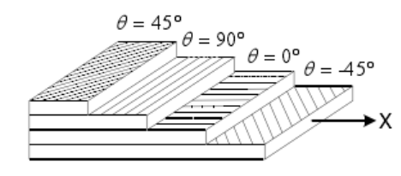

Figure 11 Composite laminate board structure

(2) Sandwich board structure

The sandwich board structure composite material, as shown in Figure 12, is a three-layer composite board composed of three parts, namely the upper surface layer, the lower layer and the middle layer sandwich part, which are combined by gluing. The upper and lower layers are laminated composite materials with greater strength and rigidity and thinner surface thickness, and the middle layer sandwich is generally a honeycomb-shaped lightweight material. Due to the characteristics of its own special structure combination, the sandwich board structure has high specific strength and specific rigidity, simple structure and strong design; coupled with this special connecting method of gluing, it has good fatigue resistance, damping and shock absorption, heat insulation, sound insulation and other properties.

In terms of mechanical properties, when the sandwich board structure is affected by the bending moment, the upper and lower layers bear more bending moment than the middle layer sandwich core, so the upper and lower layers should have higher specific strength and specific stiffness. The middle layer sandwich core mainly bears the shear stress generated when the sandwich structure is loaded, and the upper and lower layers bear much less shear stress than the middle layer sandwich core because of the thinner thickness. The middle layer sandwich core connects the upper and lower layers, and acts as a fixed support. In terms of the shear stress it bears, it ensures the rigidity of the sandwich structure and enhances its bending and fracture resistance.

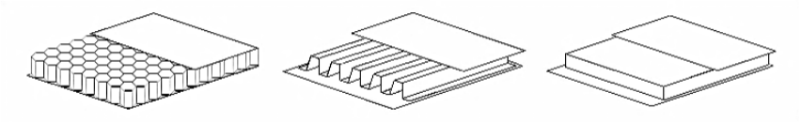

(a) Honeycomb core (b) Corrugated core (c) Foam core

Figure 12 Composite sandwich board structure

(3) Filament winding structure

The filament winding structure is a special structure formed based on the fiber weaving winding processing technology. The specific production method is to immerse the woven fiber in the resin, and then evenly wind it on the mold, perform high-temperature curing, remove the mold, etc., and then get the desired finished product.

Filament winding processing technology is a technology for fiber production. This technology has been developed earlier and has been widely used in production; compared with other processing technologies, this technology can be used to carry out specific processing and production based on the environment and actual experience of the material, while ensuring the strength of the fiber itself. Under the same conditions, compared with metal, fiber-wound products can reduce the weight by 40-60%, which allows for higher specific strength. At the same time, with the continuous development of technology, coupled with the advantages of reliable quality, high temperature resistance, corrosion resistance, and mechanized convenient production methods of the filament winding structure, the filament winding structure has been widely used in various fields. In the field of automobile manufacturing, the filament winding structure is mainly used for parts such as rotating tube columns and transmission shafts. The structure diagram of the product produced by filament winding technology is shown in Figure 13.

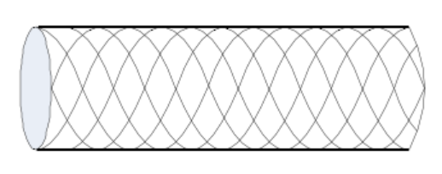Figure 13 Composite filament winding structure

2.4.3 Orthotropic Material Mechanics Model

The elastic body of anisotropic material can be in a state of equilibrium or movement under load and the premise of being continuous and uniform. It strictly obeys Hooke’s Law and has a certain degree of small deformation. In this case, the concentration of internal force caused by external force is called stress. In the three mutually orthogonal planes, that is, in the three-dimensional orthogonal coordinate system, the normal of the three orthogonal planes should be parallel to the corresponding coordinate axes. In this coordinate system, the stress component of any of the objects that meet the above conditions at any point is:

 (2.16)

Among them, are normal stress and  shear stress.

When the elastic body is deformed by external force, the stress and strain components of any point in the object are:

 (2.17)

Among them, are linear strain and tensor shear strain.

Then, by integrating the displacement equation, geometric equation and deformation coordination equation of the object, the relationship of the anisotropic elastic body can be evolved, as shown in equation 2.18:

 (2.18)

Among them, [D] is the stiffness symmetric matrix, is the engineering stiffness constant coefficient, is the engineering shear strain value, and .

In the three-dimensional orthogonal coordinate system, if any point on the elastic body of the anisotropic material is sufficient to have mutually perpendicular symmetry planes in the three directions of x, y, and z, the elastic body is said to be orthotropic. Now in the stiffness symmetric matrix [D], . In the end, the stiffness symmetric matrix [D] becomes a more convenient form, and the independent engineering stiffness constant coefficients are retained to 9, namely:  (2.19)

### 2.4.4 Strength and Failure Criteria of Composite Materials

Material strength refers to the ability of a material to resist damage when it is loaded by an external force. As the external force increases, the stress generated by the material itself gradually increases. When a certain stress limit value is reached, the material will be damaged, resulting in failure phenomena such as deformation and fracture, leading to the loss of structural integrity of the material. The stress limit value at this moment is often expressed as the strength of the material. There are many factors that affect the strength of materials, mainly due to the inherent characteristics of the material itself, such as physical and chemical properties; load conditions, such as static, dynamic, one-dimensional, and multi-dimensional loads, and environmental factors, such as temperature environment, medium conditions, etc, are all factors that play into the strength of materials.

Isotropic materials have no directionality, that is, each point of action has the same anti-pressure properties in all directions. The difference from this material is that anisotropic materials, such as composite materials, have obvious directionality, exhibit different mechanical properties in different directions, and have large differences in strength. For single-layer composite materials, there are five characteristic indexes to measure its strength. They are longitudinal tensile strength (Xt), longitudinal compressive strength (Xc), in-plane shear strength Sc, transverse tensile strength (Yt), and transverse compressive strength (Yc). For example, the longitudinal direction of the single-layer fiber composite material is the fiber direction, and the transverse direction is the direction perpendicular to the fiber. The characteristic intensity in each direction is shown in Figure 14.

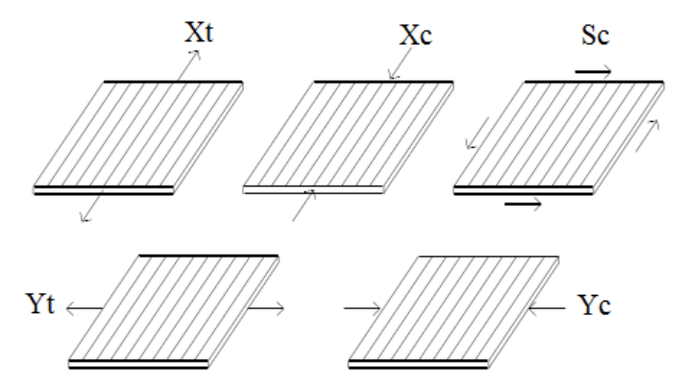

Figure 14 The characteristic strength of composite materials in all directions

In recent years, the theory of anisotropic materials has been continuously applied and developed, attracting a large number of researchers in this field. Among them, for the research on damage of anisotropic materials, scholars summarized different failure criteria based on different failure assumptions, and they were widely recognized. The more commonly used strength failure criteria include the maximum stress-strain failure criterion, the Tsai-Hill failure criterion, the Chang-Chang failure criterion, and the Tsai-Wu tensor strength criterion. The specific expression is shown below, and this article gives a brief introduction.

(1) Maximum stress and maximum strain failure criterion. It is a failure criterion proposed by designers earlier and widely used. This criterion is known for simple prediction and good prediction effect. As long as the observed strength value or stress and strain value exceeds the corresponding fixed threshold, the research object material (generally showing the characteristics of brittleness) will experience structural failure.

The conditions based on the maximum stress failure criterion of unidirectional composite materials are:

 (2.20)

The conditions based on the maximum strain failure criterion of unidirectional composite materials are:

(2.21)

Among them, is the maximum longitudinal tensile strain, is the longitudinal maximum compressive strain, is the lateral maximum tensile strain, is the lateral maximum compressive strain, and is the plane maximum shear strain.

(2) Tsai-Hill failure criterion. For the shortcomings that the maximum stress and maximum strain failure criterion is simple in its form and that the criterion cannot be used on anisotropic materials under certain circumstances, the Tsai-Hill failure criterion is proposed. Compared with the former criterion, the object curve under this criterion is smoother, the failure strength display is more reasonable, and the combination of theory and experiment is more accurate. The indication method of the failure criterion is

 (2.22)

(3) Chang-Chang failure criterion. There are 4 failure modes, which are fiber tensile failure, fiber compression failure, matrix tensile failure, and matrix compression failure.

a) When the failure mode is the fiber tensile failure mode, ,then, ,at this time there is

(2.23)

b) When the failure mode is the fiber compression failure mode, ,then, ,there is

(2.24)

c) When the failure mode is the matrix tensile failure mode, ,then, ,there is

(2.25)

d) When the failure mode is the matrix compression failure mode, ,then, ,there is

(2.26)

(4) Tsai-Wu tensor strength criterion. It is proposed on the basis of many strength criterions. When the failure mode is fiber tensile failure mode and fiber compression failure mode, the failure mode is the same as the Chang-Chang failure criterion. And when the failure mode is the matrix tensile failure mode or the matrix compression failure mode, there are

(2.27)

Among them, 1 and 2 are the longitudinal and transverse directions of the single-layer fiber composite material, respectively.

# 3. Analysis of 100% Frontal Car Crash Simulation

## 3.1 Building 100% Frontal Car Crash Model with FEA

### 3.1.1 Simplifying Vehicle Model

First of all, this paper establishes the finite element model of the car body in white, as shown in Figure 15, it can be seen that the whole body in white model is more complicated and the number of grid cells is huge. In fact, during the entire process of a car collision, the deformed structure of the car is mainly the front compartment of the car, and the deformation of the components behind the A-pillar is small or almost no deformation occurs. Taking this into account, in order to reduce the computer’s calculation time and improve work efficiency, the idea of simplification of the finite element model is adopted. Under the premise of satisfying the quality and keeping the center of mass consistent, the parts that have little influence on the collision result behind the A-pillar of the car model are cut off and are replaced by mass points. The model has a total of 226,503 elements, and the grid is divided by 5~10mm shell elements. According to the E-NCAP, the collision speed used by this model is 50km/h, the acceleration applied to the car model is 9.8m/s2, and the collision time is 120ms. The simplified model is shown in Figure 16 below;

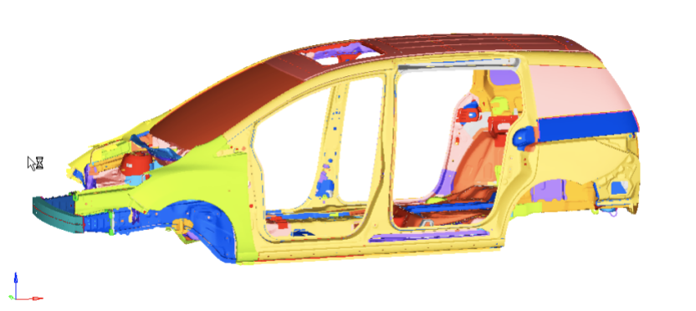

Figure 15 Automobile FEA model

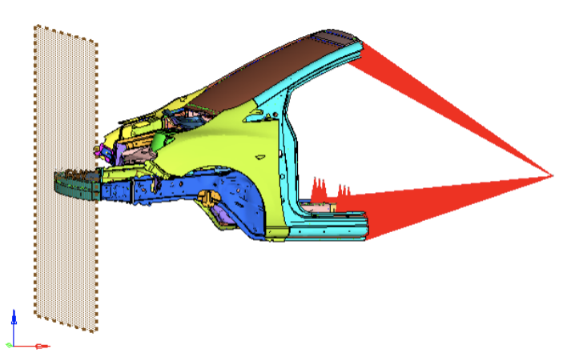

Figure 16 Automobile FEA model simplified

### 3.1.2 Finite Element Meshing

In the process of analyzing the models, the quality of meshing can not only affect the subsequent calculation process, but also affect the results after the simulation; if the quality of the division is not reasonable, it will directly cause an error in the middle of the calculation, or even stop the entire process. So, mesh division is an important basis for FEA. Because the white automobile body parts contain a large number of plate metal structures, a huge number of shell element grids will be generated when they are divided. Plus, the quadrilateral grid can better reflect the theory of force transfer changes, Therefore, the number of triangular element meshes should be controlled when dividing the mesh, and quadrilateral element meshes should be the main type.

Generally speaking, the smaller the size of the quadrilateral element grid, the more accurate the finite element simulation model will be. Although a mesh with a smaller element size can improve the accuracy of the finite element model, when dividing the mesh, it must be combined with actual problems. When the grid is divided into smaller sizes, it will inevitably lead to a sudden increase in the total number of grids in the finite element model, an increase in the calculation cycle, and a decrease in work efficiency. For the collision simulation analysis of the automobile finite element model, it is very hard to implement, but the result of the simulation calculation requires higher model accuracy. In order to ensure the validity of the calculation results, according to engineering experience, the size of the unit grid is generally controlled at 10mm. However, the front compartment of the car has a greater impact on the collision performance during a car collision, so the grid size should be reduced to 5mm to improve accuracy. When the meshing of the vehicle model is finished, the overall mesh quality should be checked to further ensure the validity of the mesh of the finite element model. The standard for 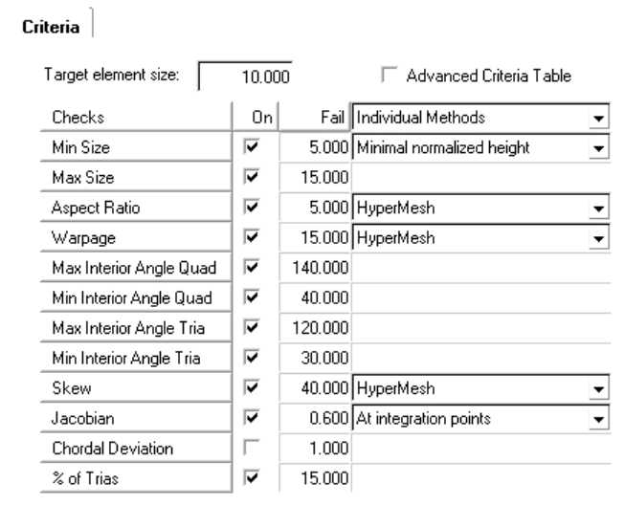checking the grid is shown in Figure 17; the number of triangular elements is 8795, accounting for 3.88% of the total number of elements.

Figure 17 Automobile FEA mesh standard

### 3.1.3 Defining Material and Properties

The 100% frontal collision finite element model of the car established in this paper is mainly a simplified body-in-white model. The model structure is basically composed of sheet metal parts, and the front windshield is also a sheet shape, so the units are shell units. . The metal plates are all made of MAT_24 material in the LS-DYNA material library, that is, the piecewise linear plastic material model (*MAT_PIECEWISE_LINEAR_PLASTICITY); the windshield uses the MAT_123 material in the LS-DYNA material library, that is, piecewise linear Plastic elastoplastic material model (*MAT_MODIFIED_PIECEWISE_LINEAR_PLASTICITY); the fixed rigid barrier used in the model is the MAT_20 material in the LS-DYNA material library, which is the rigid body material model (*MAT_RIGID). Due to the large number of panels in this model, the thickness of each panel is different, so we cannot list them all. The thickness of the front bumper beam is 1.8mm.

### 3.1.4 Time Step Control

LS-DYNA controls the time step by using a variable time step increment solution, where the time step is the time spent on finite element integration for each step. Usually, the LS-DYNA program software will calculate the critical time step value of each unit at the beginning, and the standard for the next integration time step is to select the smallest value of the critical time step generated in the previous step. In LS-DYNA, the time step length can be adjusted according to the actual problem requirements. According to formula (3.1), it is shown that when the volume remains unchanged, the mass increases and the density increases, thereby increasing the time step length. This is called the mass scaling method.

 (3.1)

 is the characteristic length of the element, is the element density, and is the elastic model.

Researchers usually use this mass scaling method to increase the time step to shorten the calculation cycle and improve work efficiency. However, if the adjusted time step is too large, which will cause unstable calculation and decreased accuracy of calculation results. After mass scaling is over, the mass change trend must be checked. If the mass of the entire model changes beyond a certain range, the reliability of the model will decrease. Generally, based on actual engineering experience, the percentage increase of the overall mass of the vehicle model during the collision process cannot exceed 5% of the total mass, otherwise, the time step needs to be readjusted.

### 3.1.5 Controlling Hourglass

The so-called hourglass model is actually a finite element model element that has no stiffness, no ability to resist deformation, and no stress generation. It is also called a zero-energy model. When the hourglass is large, the total energy of the finite element model will not be conserved, which will affect the reliability of the calculated model. Therefore, before solving the model, the hourglass needs to be properly controlled. Generally, the hourglass can be controlled by adjusting the overall viscosity of the model, increasing the overall or partial stiffness of the model, and using the full integration method. When the hourglass energy does not exceed 5% of the total energy, the hourglass energy curve is considered reasonable.

### 3.1.6 Model Connection Settings

After the meshing and other related work is completed, the metal sheet parts need to be connected according to the actual conditions of the body parts. Generally, the commonly used connection methods in actual engineering are: solder joint connection, bolt connection, rivet connection, hinge connection, adhesive connection, etc. Because the white automobile body part contains a large number of sheet metal parts, and the actual sheet metal parts are usually assembled together by welding, the simplified model of the whole vehicle in this article contains a large number of welding joint simulations. In HyperMesh software, SPOTWELD simulation connection in the 1D menu is selected for the solder joints. This connection method ensures the effectiveness of the connection between the sheet metal parts while reducing unnecessary work, especially when there is a large number of parts. The step of establishing the solder joint material model is omitted. For example, the schematic diagram of the solder joint connection between two metal sheet parts in the car model is shown in Figure 18.

Figure 1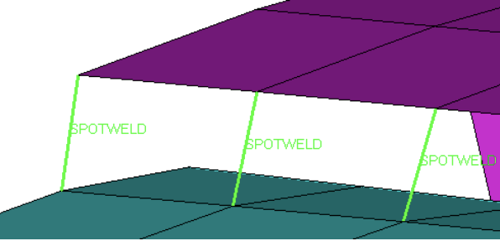8 Solder joint connection

### 3.1.7 Contact Settings

The finite element model contact setting is aimed at different parts or two adjacent faces between the same parts. If the adjacent surfaces are not controlled for contact, then they will penetrate each other, and there will be out-of-range velocities and negative volume in brick element during calculation. This phenomenon would cause the calculation to be suspended.

The common contact types in finite element are: single-surface contact, point-surface contact and surface-surface contact. In the simulation analysis of automobile finite element collision models, most of the contact forms are set as single-surface contact and surface-surface contact. Generally speaking, automatic single surface contact (*CONTACT _AUTOMATIC _SINGLE _SURFACE) definition is required for the entire finite element car model, because the car model has many plates, the shape of the steel plate stamping is also different, and in a smaller area the boards in the same direction have the appearance of multi-layer boards. The purpose of this automatic single-surface contact definition is to avoid the phenomenon of penetration between the thin-plate parts and itself. However, in this setting, when some parts continue to experience penetration, these parts must be individually defined. The contact between them is usually defined as the type of automatic surface contact (*CONTACT _AUTOMATIC _SURFACE _TO _SURFACE).

## 3.2 Analyzing Result from Simulation

In this research paper, the automobile finite element model was established in the HyperMesh software and pre-processed. The processed model results are output in the K file format, and then the file data is submitted to the LS-DYNA software for calculation. The results can be opened and viewed in the LS-PrePost program in the LS-DYNA software.

### 3.2.1 Analyzing Image Sequence During Collision

The key sequence diagram 19 of automobile collision shows the changes of the automobile finite element model in the process of simulating 100% frontal collision. The total collision time is 120ms. The car is driving in the positive direction of the fixed barrier at a speed of 50km/h. At the moment of collision, first the front cross member of the bumper comes into contact with the fixed barrier. The bumper is first squeezed and deformed, and then the collision force is transmitted to the energy absorbing box through the front cross beam. Because of the special structural characteristics of the energy absorbing box, most of the impact force of the collision is absorbed, so the energy absorbing box finally undergoes obvious deformation, and the front cross beam of the bumper because of its elasticity, and at the end of the collision, can return to its original shape to a certain extent.

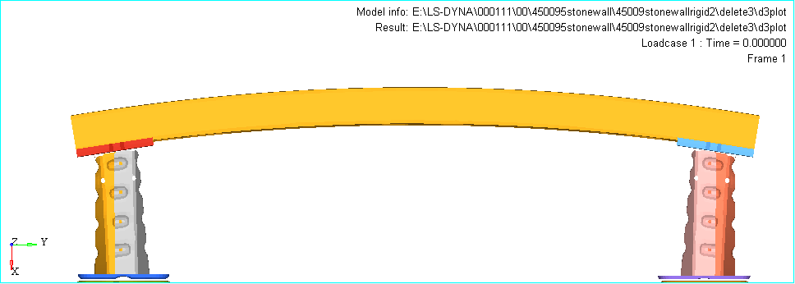

(a)

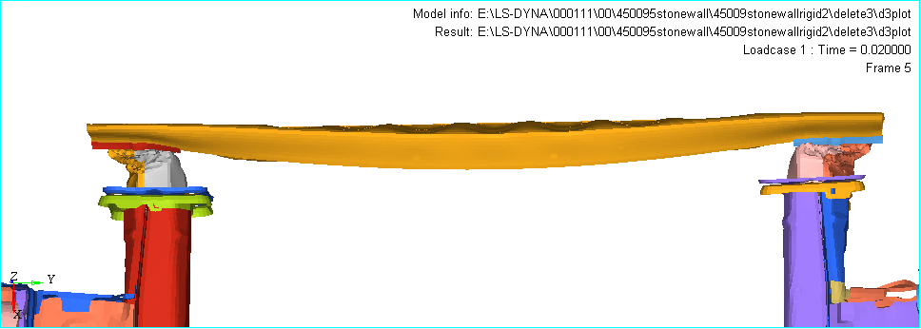

(b)

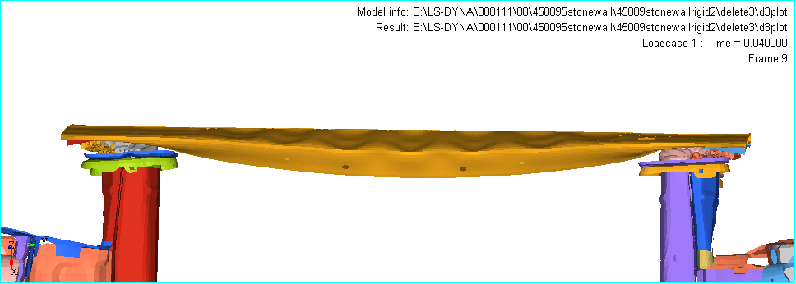

(c)

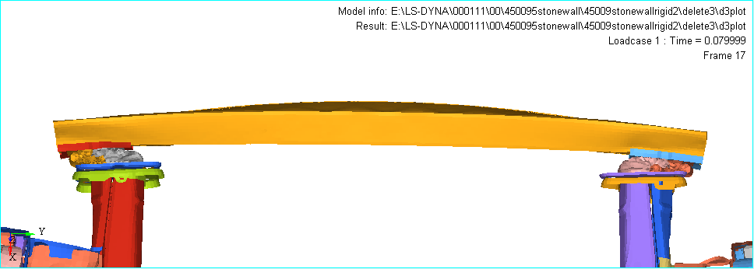

(d)



(e)

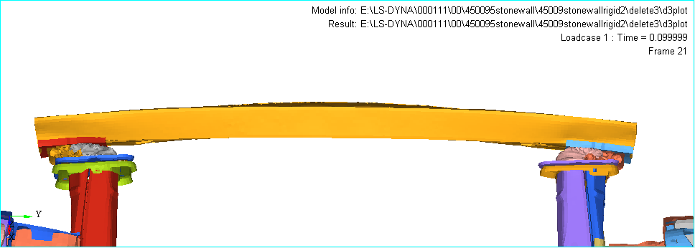

(f)

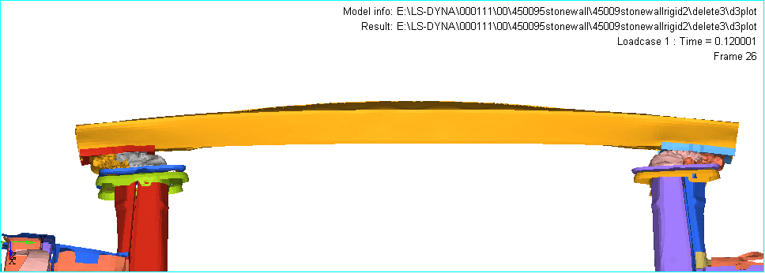

(g)

Figure 19 Sequence of automobile collision

### 3.2.2 Energy Change

From the energy curve figure 20, it can be found that the entire collision process is the process of converting kinetic energy into internal energy; the total energy curve C basically remains in a horizontal form, representing that the total energy meets the necessary conditions for maintaining conservation; the hourglass energy and the maximum value of slip energy is less than 5% of the maximum value of kinetic energy, which means they are within the acceptable range.

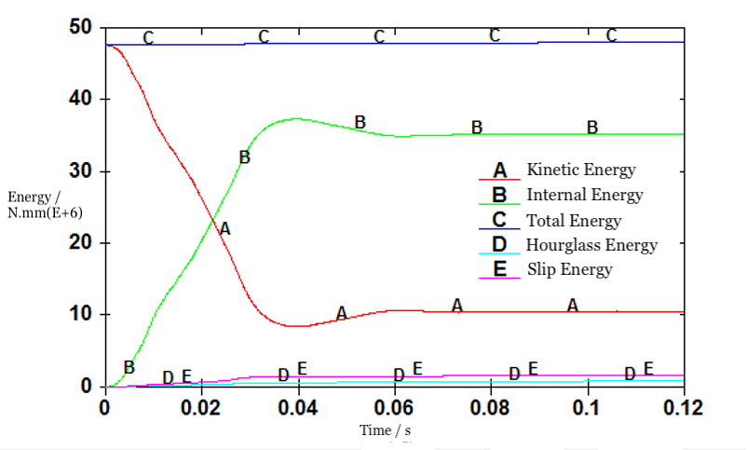

Figure 20 Energy curve

### 3.2.3 Increase in Mass

From the mass increase curve graph 21, it can be found that the maximum value of the mass increase percentage is 3.54%, which is lower than the empirical standard of 5%. Since both the energy change and the mass increase change curve are within the acceptable range, the simulation results of the model are considered credible and worthy of analysis.

Figure 21 Mass increase curve

### 3.2.4 Analysis of Impact Force of Bumper Collision

As shown in Figure 22 of the bumper impact force change curve, it can be seen that the bumper impact force has undergone a sharp increase in the first 30ms, basically an instantaneous change from a zero value to a maximum value of 1009.92N; after 30ms, the impact force of the bumper began to gradually decrease.

Figure 22 Bumper impact force change curve

3.2.5 Bumper Deformation

As shown in Figure 23 of the bumper intrusion volume change curve, it can be seen that the bumper intrusion volume quickly reaches the maximum value of 223.178mm at about 10ms. After 10ms, the bumper intrusion volume begins to slowly decrease dynamically, and the final intrusion volume is 119.564mm. Both the maximum intrusion amount (223.178mm) and the final intrusion value (119.564mm) have far exceeded the bumper safety threshold of 50mm. The collision process has caused damage to the rear bumper components. Therefore, it is necessary to optimize it.

Figure 23 Bumper intrusion volume change curve

### 3.2.6 Bumper Energy Absorption Analysis

As shown in Figure 24 of the bumper energy absorption curve, it can be seen that the energy absorption of the bumper is a process of rapid change in the first 30ms. At about 30ms, the energy absorption value reaches the maximum value of 8.109KJ; after 30ms, the energy absorbed by the bumper is transformed into other forms of energy under the exertion of external force, and then rapidly decreases, finally reaching a stable value.

Figure 24 Bumper energy absorption curve

### 3.2.7 Upward Displacement of Steering Column Hole

As shown in the graph 25 of the upward displacement at the steering column hole change curve, it can be seen that: in the first 20ms, the upward displacement at the steering column hole is a slowly increasing process; at about 20ms, the steering column hole moves upward until it reaches a maximum value of 4.037mm; between 20ms and 40ms, the upward displacement of the steering column hole is a descending process. At 40ms, the displacement reaches a minimum of -7.115mm; after 40ms, the upward displacement of the steering column hole began to increase again, and the maximum displacement reached 87.625mm at 120ms. Obviously, the upward displacement of the steering column hole at this time has exceeded the 80mm specified by the E-NCAP evaluation standard, causing certain damage to the driver's head or chest. Therefore, this is where it is urgently needed to be optimized.

Figure 25 Upward displacement at the steering column hole change curve

### 3.2.8 Backward Displacement of the Steering Column Hole

As shown in Figure 26, it is clear that during the collision of the whole vehicle, the backward displacement at the steering column hole is increasing within the range of 0~120ms, and each incremental increase becomes larger as well. When it reaches 120ms, its displacement reaches the maximum value: 98.566mm. Obviously, the rearward displacement of the steering column hole at this time does not exceed the 100mm specified by the E-NCAP evaluation standard, but the maximum value of the displacement is not an optimal value. Therefore, it is also something that needs to be optimized.

Figure 26 Backward displacement at the steering column hole change curve

## 3.3 Building Model with Composite Materials

### 3.3.1 Equivalent design for Front Bumper Beam

In actual engineering, when carbon fiber composite materials are used to replace the original object materials, the commonly used design methods are as follows. (1) Equivalent design: while maintaining the same strength and rigidity under the same load conditions, it replaces the original material parts with carbon fiber composite materials of the same or smaller shapes. The equivalent design method can be subdivided into equal-thickness design, equal-rigidity design, and equal-strength design; (2) Laminate netting design: it means that regardless of the stiffness and strength of the matrix, only the rigidity and strength of the composite material in the laminate direction are necessary; (3) Laminate order design: it refers to the use of different angles of various laminate structures to analyze the corresponding rigidity or strength, and then select the appropriate angle for the design.

The front beam of the automobile bumper is mainly affected by bending deformation during a collision. The designer should consider the bending stiffness in this direction when designing its thickness to meet the conditions required to withstand the collision. Therefore, in order to make the rigidity of the carbon fiber composite material and the aluminum alloy material of the automobile bumper front beam equal in thickness and bending stiffness, this paper adopts the stiffness equivalent design method.

**l**

b

h

M

M

Figure 27 Material plate bending

In the process of simulating the collision of the automobile finite element model, the front cross beam of the automobile bumper and the fixed rigid barrier first contact and collide, and the front cross beam is subjected to the bending load, as shown in Figure 27, the stress formula is

 (3.2)

In the formula, M is the bending moment, l is the length of the material plate, E is the Young's modulus, I is the moment of inertia, and the moment of inertia is expressed as

** (3.3)

In the formula, b and h are the width and thickness of the material plate respectively. In order to reduce the influence of the numerical noise caused by the different shapes and structures of the target parts, the front beam of the carbon fiber composite bumper and the front beam of the original aluminum alloy bumper in the automobile finite element model in this paper maintain the same state in terms of structural shape design. The equal stiffness design formula is

 (3.4)

Combining formulas (3.3) and (3.4), the following equations are obtained for thickness h and Young's modulus E:

 (3.5)

For example, the thickness of the front beam of the original aluminum alloy bumper is 1.80mm. According to the equation (3.5) and the mechanical properties of the material, as shown in Table 3.1, the thickness of the front beam of the carbon fiber composite bumper can be calculated as 1.92 mm.

Table 1 Comparison of mechanical performance parameters of selected materials

|  |  |  |  |  |  |  |
| --- | --- | --- | --- | --- | --- | --- |
|  | Elastic Modulus (GPa) | Shear Modulus (GPa) | Poisson's Ratio | Density  (Kg/m3) | Yield Strength  (MPa) | Tensile Strength  (MPa) |
| Aluminum Alloy Material | 68.2 | 26 | 0.33 | 2700 | 80 | 173 |
| Composite material | 56.5 | 12.5 | 0.3 | 1455 | / | 823.1 |

### 3.3.2 Establishment of Finite Element Model of Composite Bumper

The previous section 3.3.1 calculates the total thickness of the front bumper beam of the carbon fiber composite material type according to the equal stiffness alternative design method to be 1.92 mm. Since the material is limited by the manufacturing process, this paper uses a total of ten layers for layering, and the thickness of each layer is 0.192mm; then the carbon fiber composite front bumper beam is modeled by finite element layering. The defined material type is MAT_54 material in the LS-DYNA material library, which is the composite material damage model.

### 3.3.3 Graph of Total Energy in the Composite bumper model.

From Figure 28, we can see the changing curves of various energies of the carbon fiber composite bumper in the finite element model. From the model, we know that the control of hourglass energy and slip energy are still within the acceptable range, as expected.



Figure 28 Composite material energy curve

### 3.3.4 Comparison and Analysis of Collision Response Indexes of Two Kinds of Material Bumpers

(1) Comparison of peak force of bumpers made from two materials

It can be seen from figure 29 below that after the use of carbon fiber composite materials, the peak impact force of the bumper has dropped from 1006.920N to 981.147N, and the rate of change is -2.560%. The carbon fiber composite bumper is compared with the previous aluminum alloy bumper in the peak force target response, and the effect is basically the same, so it can be substituted for the next step of optimization.

Figure 29 Peak force of two material bumpers

(2) Comparison of the amount of bumper intrusion between the two materials

It can be seen from the figure 30 below that after the use of carbon fiber composite materials, the peak value of the bumper intrusion has increased from 223.178mm to 243.161mm, and the rate of change is +8.95%. Comparing the carbon fiber composite bumper with the previous aluminum alloy bumper, the effect is basically the same, but there is an undesirable change that increases the intrusion amount of the bumper, so it needs to be carried out in the next step optimization.

Figure 30 Bumper intrusion volume of two material bumpers

(3) Comparison of energy absorption of two kinds of material bumpers

As can be seen from the figure 31 below, after the use of carbon fiber composite materials, the peak energy absorption of the bumper has risen from the original 7.239KJ to 7.643KJ, with a change rate of +5.581%. The effect after replacement is not very obvious, so further optimization is needed.

Figure 31 Energy absorption of two material bumpers

1. Figure 32, comparison of the upward displacement of the two materials at the steering column hole, the bumper using the original aluminum alloy material and the bumper using the carbon fiber composite material respectively correspond to the collision response results. Curves A and B are roughly the same, and both obtain a maximum value with an insignificant difference at about 20ms and a minimum value with an insignificant difference at about 40ms, and finally, both reach the maximum at 120ms. After replacing the bumper material, the upward displacement of the steering column hole is reduced from 87.625mm to 82.768mm, and the changing rate is -5.54%. Obviously, the change is not very obvious. Secondly, the upward displacement of the steering column hole of 82.768mm still exceeds the 80mm specified by the E-NCAP evaluation standard, causing certain damage to the driver's head or chest. Therefore, this is a place where this research needs to further optimize.

Figure 32 Upward displacement at the steering column hole of the two materials

(5) Figure 33, comparison of the backward displacement of the two materials at the steering column hole shows the backward displacement of the steering column hole of the two materials. Curves A and B are approximately the same, and both reached the maximum at 120ms at the end. After replacing the bumper material, the backward displacement of the steering column hole was reduced from 98.566mm to 92.251mm, and the changing rate was -6.41%. Obviously, the backward displacement of 92.251mm at the steering column hole does not exceed the 100mm specified by the E-NCAP evaluation standard.

Figure 33 Backward displacement at the steering column hole of the two materials

# 4. Conclusion

In this chapter, we used HyperMesh software to establish a finite element simulation model of a 100% overlapping frontal collision of a car, simplified the processing of the finite element model, and performed meshing and quality inspection, material definition, time step control, hourglass setting, connection setting, and contact setting -- a series of pre-processing. We then submit the processed files to LS-DYNA for calculation, check the result files, and check the feasibility of the model. According to the results of the energy change curve and the mass increase coefficient curve, the finite element model of the aluminum alloy bumper is credible. Then, the aluminum alloy bumper was replaced by a substitution with equivalent stiffness, and the finite element simulation model of the carbon fiber composite bumper was further established. After re-testing the feasibility of the newly established finite element model, the impact force change of the bumper, the change of the bumper intrusion, the energy absorption of the bumper, the upward displacement of the steering column hole and the backward displacement of the steering column hole before and after the replacement material during the car collision were compared, analyzed and evaluated.

# 5 Reference

1. L Kiran, Shrishail Kakkeri, Shridhar Deshpande. Proposal of hybrid composite materials for light commercial vehicle chassis. Materials Today, 2018,5(11): 24258-24267.
2. Dong-Hyun Kim, Ku-Hyun Jung, et al. Improving pedestrian safety via the optimization of composite hood structures for automobiles based on the equivalent static load method. Composite Structures, 2017,176: 780-789.
3. Kim D H , Choi D H , Kim H S . Design optimization of a carbon fiber reinforced composite automotive lower arm. Composites Part B Engineering, 2014, 58(8):400–407.
4. Do-Hyoung Kim, Hyun-Gyung Kim, Hak-Sung Kim. Design optimization and manufacture of hybrid glass/carbon fiber reinforced composite bumper beam for automobile vehicle. Composite Structures, 2015, 131:742-752.
5. Deveci H A , Artem H S . Optimum design of fatigue-resistant composite laminates using hybrid algorithm. Composite Structures, 2017, 168:178-188.
6. Liu P F , Xing L J , Zheng J Y . Failure analysis of carbon fiber/epoxy composite cylindrical laminates using explicit finite element method. Composites Part B: Engineering, 2014, 56:54-61.