Increasing efficiency of Personal Gas Conversion system for RuralHomes
Edward Fujiwara

Introduction
Methane gas is a common byproduct in any process of rot and degradation of organic matter. This gas, when decomposition occurs, is emitted directly into the atmosphere. Methane is the simplest alkane hydrocarbon that exists. Its chemical formula is CH4. This means that there are four atoms of hydrogen and one of carbon, which are linked by covalent bonds. Methane is found in nature in the form of gas at normal temperatures and pressures. In addition, it is colorless and odorless, despite being produced by the rot of plants. It is a non-toxic gas, and the only real danger is that of burns if it were to ignite. There are several ways to generate methane gas in homes, and the amount of methane gas generated by the decomposition of organic matter varies depending on the type of matter in question. An experiment was designed to measure the efficiency, as a relationship between the amount of raw material and the amount of gas generated, of three different mixtures of organic matter: 1. food remains of a home; 2. animal waste (excrement) 3. equal parts mixing of food debris and animal waste. The results allowed to conclude which of the three mixtures is the one that grants the highest efficiency in methane gas generation and which would be the most suitable for methane gas generation systems for homes, in order to occupy less space generating equal amount of gas.

Hypothesis
Methane gas can be generated in sufficient quantities to provide energy for a rural home, using a homemade biodigester and adequate amounts of food waste and animal waste.

Materials and Methods
General process
1. Bibliographical investigation to know amount of methane gas needed to run a home stove for a family of 5 (average family members in Guatemala)
2. Build 3 methane gas generation systems with easily accessible parts, with 1-gallon capacity each. One for control purposes, the other for mixture experimentation.
3. On biodigester 1: Fill with clean water and ½ pound of food waste. After at least 3 weeks measure amount of methane gas generated. Measure amount of gas twice a week.
4. On biodigester 2, add water and a mixture of animal waste and food waste totaling ½ pound. On biodigester 3, add ½ pound of animal waste.
5. Once every two weeks, add ¼ pound of the respective mixture to each experimentation unit.
6. Measure amount of gas generated on each experimentation unit twice a week for six weeks.

Materials for each unit
1. One-gallon plastic container (similar to big soda bottles)
2. 50cms plastic hose
3. Tape
4. Rubber balloon
5. Hot glue
6. Funnel
7. Waste, according to each mixture
8. Paper for data collecting
The main objective of the experiment is to determine the most efficient waste mix, which generates an adequate amount of gas for a rural household in Guatemala, in a small space and with easily accessible materials. Derived from this, it was decided to have three equal experimentation units, in order to generate methane gas with different waste mixtures. The three units were built by placing a hose for the generated gas, and a balloon at the end of the hose. The amount of gas generated was determined by measuring the circumference of the globe, keeping a track of its increase and relating the circumference to the volume of gas generated. The measurements taken twice a week were directly from the circumference of the globe. At the end of the experiment, the respondents allowed to determine which of the three experimentation units is the most efficient, and conclusions about its relevance for use in rural homes in Guatemala can be issued.
Results
Experimental unit 1
Food waste from a household
Experimental unit one was established using half a pound of food waste from a Guatemalan household mixed with a liter of water. The biodigester was left in a dark place, under cabinets in the laboratory where the experiment was performed. The biogas rot and generation procedure began five days later, however, it was left three weeks before starting the measurements on the globe, so that in the first measurement there was already a circumference of 6.5 centimeters. From this measurement, two weekly measurements of the circumference of the globe placed at the end of the system were made. Applying the circumference / Pi formula, with each measurement the diameter was located, and with the diameter, applying the volume formula of a circumference, the volume of accumulated generated gas was obtained. With experimental unit one, gas generation steadily increased with a linear trend, evident when placing the trend line on the graph. In total, 156.3885 cubic centimeters of gas were generated in 9 weeks (3 weeks of initial generation and 6 weeks of measurements).
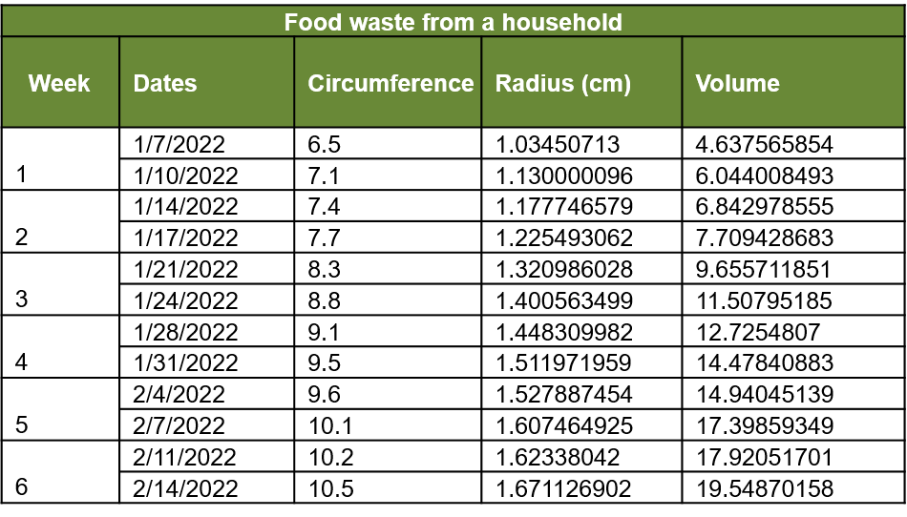
Table 1, Gas volume from food waste only

Figure 1, Linear trend observed for food waste only
Experimental unit 2
Food waste from a household and animal waste (chicken waste from a family farm)
Experimental unit two was established using half a pound of waste, with a mixture of equal parts of food waste from a Guatemalan household and chicken waste, mixed with a liter of water. The biodigester was left in a dark place, under cabinets in the laboratory where the experiment was performed. The biogas rot and generation procedure began two days later, however, it was left three weeks before starting the measurements on the globe, so that in the first measurement there was already a circumference of 6.7 centimeters. From this measurement, two weekly measurements of the circumference of the globe placed at the end of the system were made. Applying the circumference / Pi formula, with each measurement the diameter was obtained, and with the diameter, applying the volume formula of a circumference, the volume of accumulated generated gas was obtained. With experimental unit one, gas generation steadily increased with a linear trend, evident when placing the trend line on the graph, and it had an exponential increase in the last four measurements. With this mixture, the rotting process started three days earlier, and the first measurement was slightly higher than with unit 1. In total, 263.856 cubic centimeters of gas were generated in 9 weeks (3 weeks of initial generation and 6 weeks of measurements).

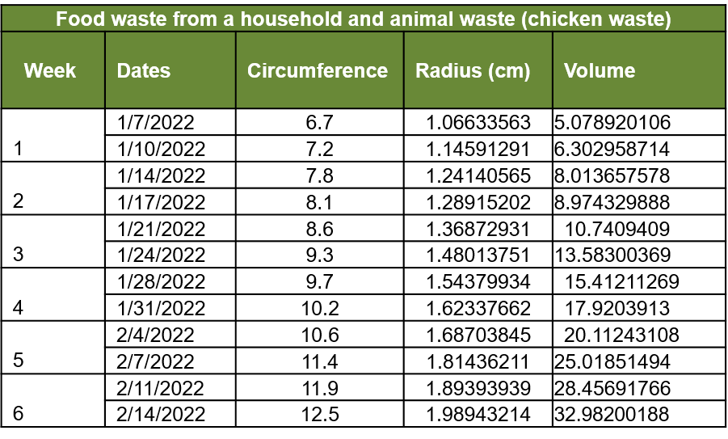
Table 2, Gas produced from both sources of wastes

Figure 2, Exponential trend observed for the combination of two wastes
Experimental unit 3
Animal waste (chicken waste from a family farm)
Experimental unit three was established using half a pound animal waste (chicken waste), mixed with a liter of water. The biodigester was left in a dark place, under cabinets in the laboratory where the experiment was performed. The biogas rot and generation procedure began seven days later, however, it was left three weeks before starting the measurements on the globe, so that in the first measurement there was already a circumference of 5.4 centimeters. Given that animal waste is a form of mater that has already been digested once, it has a higher amount of bacteria but a smaller amount of methane left. From the first measurement, two weekly measurements of the circumference of the globe placed at the end of the system were made. Applying the circumference / Pi formula, with each measurement the diameter was obtained, and with the diameter, applying the volume formula of a circumference, the volume of accumulated generated gas was obtained. With experimental unit one, gas generation steadily increased with a linear trend, evident when placing the trend line on the graph, having a very slow increase in generation. With this mixture, the rotting process started four days later compared to experimental unit 1, and the first measurement was slightly lower than with unit 1. In total, 66.60675 cubic centimeters of gas were generated in 9 weeks (3 weeks of initial generation and 6 weeks of measurements), a considerably smaller amount then units one and two.

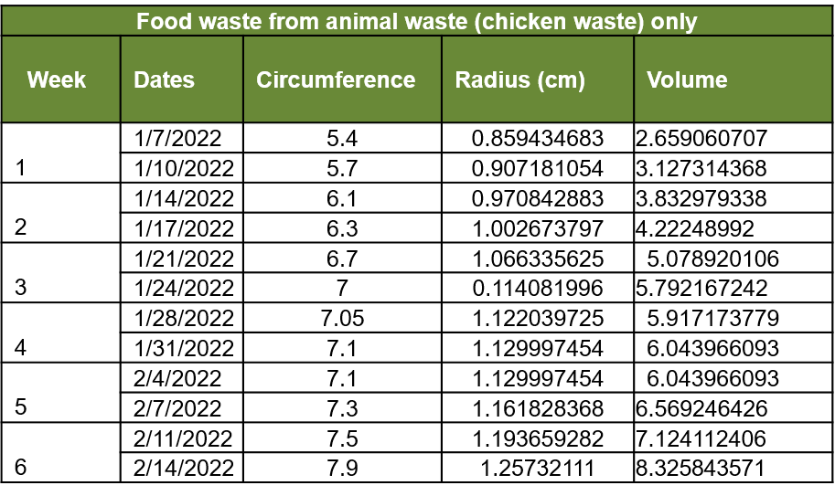
Table 3, Gas produced from animal wastes only

Figure 3, linear trend observed for the animal wastes only

Discussion
The three experimentation units presented different results. In unit one, the increase in methane gas production was constant, in a linear fashion. In unit two, production showed exponential growth after four weeks. In unit three, production was much smaller, and slower. Taking into account the characteristics of the process of decay of matter, where bacteria of different types act and emit methane gas in the process, it is evident that the contribution of bacteria from animal waste to food waste increased the efficiency of system 2. The system 3 was less efficient because the matter used was already degraded and the bacteria present had no more new matter to degrade. System one was efficient, but in a lesser way than system 2, since it takes more time for bacteria to enter and start the decay process. In general, it is clear that it is important to have an equivalent mixture of new matter (food waste) and already degraded matter (animal waste), to increase the efficiency of a biogas generation system and to have a generation system that can be used instead of propane gas or biomass burning in rural areas of Guatemala. It is also important to show that the system can be armed with cheap materials, and even recycled, and can be established without deep knowledge in this area. Once established, a biogas generation system is self-sufficient and requires little maintenance.

Conclusions
A home biogas generation system can be built with easy-to-obtain, cheap, and even recycled materials, and it can be built in such a size that it can be placed inside a home's kitchen cabinet. A mixture in equal parts of food waste and animal waste provides the amount of new organic matter, and bacteria already activated, to obtain adequate efficiency for a biogas generation system that can replace propane gas or biomass burning, in rural homes of Guatemala. Most Guatemalan households have small chicken farms from which animal waste can be obtained. A biogas generation system can easily be self-constructed without in-depth instruction on the issue of gas generation. A system of generation of whiskers, once built and established is self-sufficient and requires little maintenance. The generation of biogas, with the aforementioned mixture of matter for greater efficiency, is a suitable alternative for cooking in Guatemalan rural homes. This guarantee a closure in the material cycle and reducing the organic waste that gets to be thrown in garbage dumps, taking advantage of the gas that in any way would be generated and dispersed to the atmosphere by the natural process of decomposition.
Reference
1. Amon, T., Amon, B., Kryvoruchko, V., Zollitsch, W., Mayer, K., & Gruber, L. (2007). Biogas production from maize and dairy cattle manure—Influence of biomass composition on the methane yield. Agriculture, Ecosystems & Environment, 118(1-4), 173–182. doi: 10.1016/j.agee.2006.05.007
2. Bouallagui, H. (2003). Mesophilic biogas production from fruit and vegetable waste in a tubular digester. Bioresource Technology, 86(1), 85–89. doi: 10.1016/s0960-8524(02)00097-4
3. Themelis, N. J., & Ulloa, P. A. (2007). Methane generation in landfills. Renewable Energy, 32(7), 1243–1257. doi: 10.1016/j.renene.2006.04.020
4. Viswanath, P., Devi, S. S., & Nand, K. (1992). Anaerobic digestion of fruit and vegetable processing wastes for biogas production. Bioresource Technology, 40(1), 43–48. doi: 10.1016/0960-8524(92)90117-g
5. Weiland, P. (2009). Biogas production: current state and perspectives. Applied Microbiology and Biotechnology, 85(4), 849–860. doi: 10.1007/s00253-009-2246-7

