An adaptive grabber with the ability to actively switch between accurate grabbing and compliant grabbing
Table of Content
1 Abstract 3
2 Introduction 3
3 Theoretical design 5
3.1 Fingers 5
3.2 Base 7
4 First design 8
4.1 Structural design 8
4.2 Electronics 10
4.3 Test 11
5 Structural design 11
5.1 Actuation part design 11
5.2 Outer shell design 11
5.3 Finger position redesign 13
5.4 Base part design 15
6 Material Attachments 17
6.1 3D printing 17
6.2 Wood board 17
6.3 Metallic module 17
7 Electronics 17
7.1 Circuit boards 17
7.2 Modules 17
7.3 Motors and servers 18
7.4 Switches 18
7.5 The Whole Electronic Part 19
8 Transforming modes 19
8.1 Initial mode 20
8.2 Two-fingers mode 20
8.3 Circle mode 20
8.4 Two-sides mode 21
9 Programming and User Interface 21
9.1 Functions it achieved 21
9.2 The user interface: 22
10 Experiments (Second design) 23
10.1 Grabbing Ability experiments 23
10.2 Ultimate Grabbing Experiments 26
11 Conclusion 28
12 References 28

Abstract
For most robotics, it is hard to have both precise pinching and various grasping modes. Most of them can achieve only one which limits the usage of the hand. Moreover, for the hands which have both, an active transition between pinching modes and grasping modes is another big problem. Most hands can only grab big items but cannot pinch small things like pens and screws. It is undeniable that there are hands that can overcome all the problems mentioned above. However, these hands all have very complex structures. They usually have a lot of motors and sensors to control the movement. This makes the price of the hand high and the control of the hand difficult. In this paper, a 3-finger, 4 modes adaptive gripper with active transition capability is presented. Each finger is composed of a minimum number of components using an outer shell, a finger body, a fingertip, a belt, and a motor for flexion motion. This structure allows the finger to have the ability to both pinch and grab. At the same time, the hand also can be self-adaptive to the shape of the object. Two other motors are added for the finger’s angular movement which is changing grasping modes. The experiments including a lot of daily stuff verify the performance of the proposed gripper and prove the practical usefulness for real-world applications.
Index terms – Adaptive gripes, compliant mechanisms, grasping modes transition, robotic hands.

Introduction
Today, people use all kinds of grippers in many areas to achieve the same function as human hands – to grasp things [1-3]. However, the human hand can also do a lot of other works besides grasping things. In this case, mechanic hands are also developed to do works like using tools. This development asks mechanical hands to be more similar to a human hand. The similarity does not mean the mechanic hand needs to have five fingers, but instead a similar grasp way and mode to human hands. For instance, when a person is using a screwdriver, he will first grab the screwdriver with two or three fingers and lift it from the table since the downside of the screwdriver is closed to the table. After freeing all the faces of the screwdriver, he will hold it with his whole hand to increase the torque. After using the screwdriver, he will return to the two or three fingers mode and put it on the table. Therefore, when a gripper wants to use a screwdriver on the table, it needs to imitate the step same with people. By step, it means the change of modes. The gripper needs to change its mode smoothly so it can achieve the goal.
Using a screwdriver is a very simple example. In real-world situations, there are a lot of other more complex works. To deal with all these complex situations, scientists did a lot of research on grasping taxonomies[4-5]. These studies gave out a lot of distinctive grasp types which implies the versatility of the human hand. To realize similar capabilities, various human-like robotic hands have been developed[6]. The case is that these robotic hands use a great number of sensors and very complex structures to achieve the functions. This case hinders the spread use of these hands. Therefore, the structural complexity is also limited.
Compare with complex robotic hands, simpler hands may have less structure similarity and flexibility. However, the flexibility of these smaller robotic hands is pretty enough for most of the daily work. With the development of robotic hands, more and more designs had appeared. Here, we focus on the finger design since the finger is the main part of the robotic hand. These designs include synergy-based mechanisms[7-8], soft material mechanisms[9-11], and knuckle-used mechanisms[12-13]. These designs show great performance in some situations. But in some other situations, they cannot grab very well.
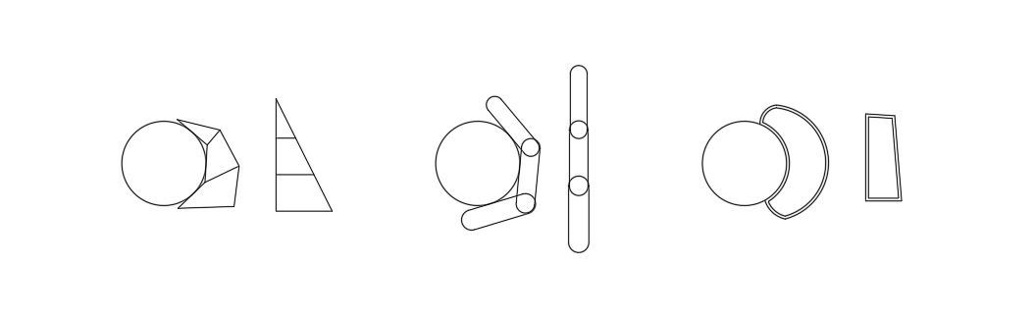
Fig 2.1 Three kinds of designs(from left to right: synergy-based mechanisms, knuckle-used mechanisms, soft material mechanisms)
One example of a knuckle-used mechanism is the hand from Katharina Hermann and his group. Below is a picture of their hand.
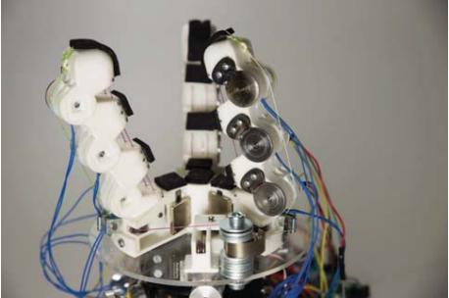
Fig 2.2 The hand of K. Hermann and his group [14]
This finger consists of three fingers. Each finger has four joints. These four joints on one finger are controlled by a tendon and one motor. Then tendon goes through each of the joints and is finally connected to the motor. Since the tendon is soft, the finger can fit with the shape of the object. Therefore, when this hand is grabbing spherical objects, it has a perfect performance. However, the position other three fingers are fixed in a circle shape. This means that when it’s grasping objects with another shape, the hand cannot fit that well. Also, this hand is not good at grabbing small objects. It is good at grabbing but not good at pinching. For instance, if the hand needs to grab a pencil, the hand cannot easily do so since the finger is too big and so cannot pinch. Also, the hand position of the fingers is in a circle shape, it is not fit for grabbing cylindrical objects.
Soft robotics can solve this problem. The soft robotic hand proposed by Jianshu Zhou and his group solved this problem. As shown in figure 2.3, his group proposed a three fingers hand. Each finger has two chambers on each side that can stretch. Especially, there is a small tip on each of the fingers.
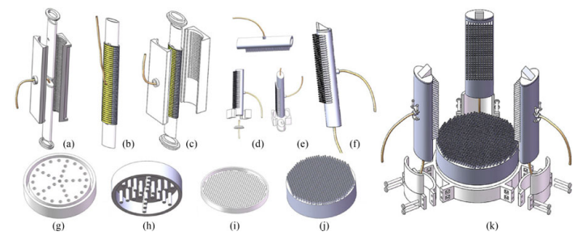
Fig 2.3 The hand of Jianshu Zhou and his group [15]
However, this hand still cannot change the position of the three fingers. This means the hand is not good at grabbing things without a spherical shape. Even though soft material can solve this problem a bit, it also causes another problem – the grasping is not tight enough. What’s more, the grip of fingers is very simple. It only has one action which is not good.
A synergy-based hand is a new kind of mechanism. Take a look at Laliberte and his group’s hand. His hand used a synergy-based structure that can fit with the object. This fitness can make sure the grabbing is tight. Also, this hand is good at pinching since it has a long tip.
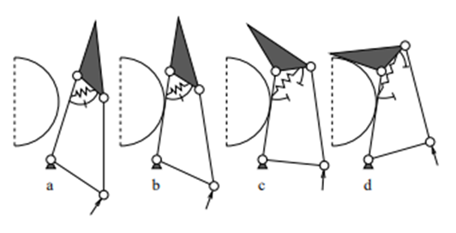
Fig 2.4 The schematic of Laliberte and his group’s hand [7]
However, this structure’s grabbing motion is pretty simple. It is difficult to fit with objects with unregular shapes. And the hand cannot have a lot of grasping modes.
As shown, each kind of hand has its benefit and shortcomings. Therefore, I am thinking about a way to fuse them[16]. Therefore, this paper proposed a three-finger four-mode robotic hand that had a really simple structure. This hand got the basic idea from another design by a group of scientists. After improving the basic design and adding new ideas, this hand can do more precise and complex grasping by changing modes smoothly and flexibly. At the same time, this hand can also hold the different shapes of things since it used flexible grasping. The remainder of this paper is organized as follows. Section 3 provided the design process of the gripper. Section 4 presents the experimental reports the evaluation results. Section 5 gives the material and the electronic part used in the gripper. Section 6 gives out the program and the interface between the user and the gripper Section 7 is a conclusion about the paper and section 8 is references

Theoretical design

Fingers
The main part of the hand is the three fingers. As mentioned in the introduction, the gripper proposed in this paper is based on Laliberte’s grasping hand [7].
Fig 3.1
The picture above is cited from his paper and shows the principle of his hand. His hand is a synergy-based type. This design can achieve precise gripping. However, the grasping type Is determined only by the contact region, which means that once the grasping type is determined, it cannot be actively changed. What’s more, the force acting on the object is added on only a few contact parts. This will cause the holding to be unstable.
To solve these questions, this paper gives out a design based on T. Laliberte’s hand. On this hand, a belt is introduced to replace the left trigger. The actuators are replaced by a rotating type instead of a pushing type,
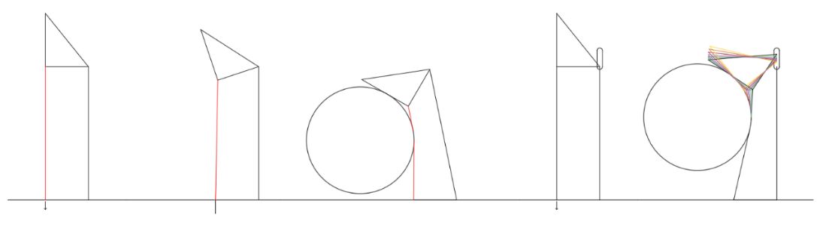
Fig 3.2 The schematic of my hand
As shown in figure 3.2, the red line in the picture is the belt. This can make sure the hand can fit with the shape of the object better so increasing the holding tightness. Therefore, as shown in the third graph of fig 3.2, the whole finger can half-surround the object.
But this is not enough, the tip is not flexible enough since there is only one position the tip can fit with the object. Therefore, a slide rail is added to the top of the finger body for the fingertip to not only rotate but also slide to have several grasping posts. As shown in the last graph in fig 3.2, each different color represents a different grasping post. Under each post, the tip of the finger is slid into a different position.
However, what can decide the position of the fingertip? In the last graph of fig 3.2, each position of the fingertip corresponds to a different belt tightness. The yellow one has the loosest belt while the black line has the tightest. Therefore, the finger should also include a structure for controlling the tightness of the belt. In fig3.2, the other end of the belt (not the one on the tip) is fixed on the ground. Instead, the end can be moved on to the structure. This structure can stretch or release the end to control the whole belt and the fingertip connected to it. As a result, we can connect all the concepts to form the theoretical design of the finger part. This design is shown in figure 3.3 below.
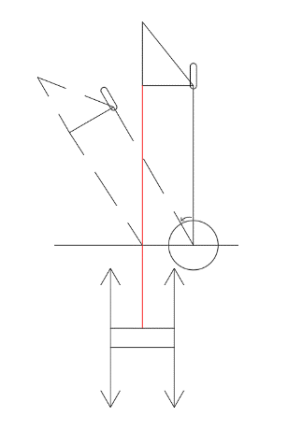
Fig 3.3 The schematic of the finger

Base
To fully grab an object, the hand should have several fingers. In this project, the hand will have three fingers. This is because one or two fingers are not enough to hold an object tightly or even hold an object. A hand with more than three fingers is too bloated according to my design. I will explain it more in the next paragraph.
To achieve the goal of having various grasping modes, the fingers on the hand should be able to rotate around a center on the finger so they change the relative position of these fingers and so to create different grabbing positions. Thus, there needs to have space for each finger to rotate. This is why adding more than three fingers is not a good idea. They will crowd together and limit the transforming of the hand.
A detail is that since all the position is relative this means that one of the fingers doesn’t need to move. It is the signpost for the other two fingers. This finger should be the middle finger since the other two fingers are symmetric. Otherwise, the other two moving fingers have different moving motions which are not necessary. This concept is shown in figure 3.4 shown below.
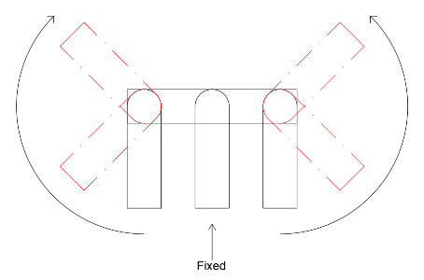
Fig 3.4 The schematic of the transformation between modes
These rotations create a lot of different grabbing positions. However, artificially controlling the rotational angle of the outer fingers is not a good idea. This is because human is not as precise as the program. Plus, wireless communication has a huge delay. There may be a big error. This difference between the ideal position and the actual position may cause problems. As a result, this hand provides three grasping modes for the user to choose and one initial mode. These three modes can cover most of the grabbing. Three grabbing modes are Two-Fingers mode, Circle mode, and Two-Sides mode. The detail of these four modes is shown in part seven.
The next step is to draw the specific design of the finger. The design is completed using SOLIDWORK which is a 3D drawing app. The material and assembling part will be explained in the “Material Attachments and Electronics” section.

First design

Structural design
The actuator part for the rotating of the finger body uses a worm and a gear. One reason why using them is that this transmission structure can make sure that the motor and the finger can be in one layer so a single finger will not be too thick. If simply add a motor on the side to drive the finger, a single finger will be so fat and so affect the function. Another reason is that this structure is a self-locked structure which means that it will block itself when it stops moving so the motor doesn’t need to keep turning when the finger had already grabbed the target object. The structure is shown in figure 4.1 below.
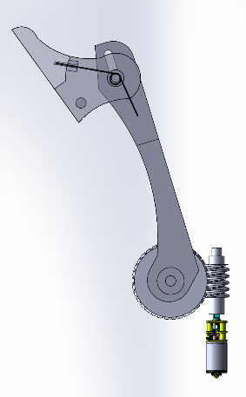
Fig 4.1 The 3D drawing of the main structure of the finger
According to the design of the actuation system, the first design of the out shell is a whole piece with a gap inside it for the finger to put in. There is an extended structure behind the gap which is used to contain the motor and the worm. Since a finger needs a lot of rotation and sliding, there needs to be a lot of axles as the rotation center and the track for the sliding parts (belt part). Thus, there are a lot of holes in the structure to fix the axles. Especially, two big holes on two sides are step holes for bearing since that part is the rotational center for the finger. The 3D drawing is shown below in figure 4.2.
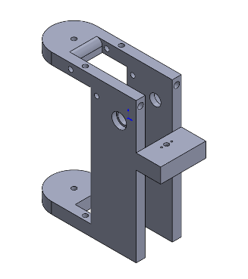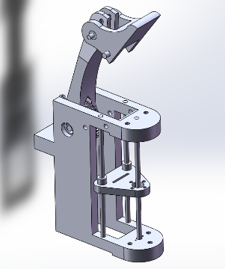
Fig 4.2 The outer shell, the whole finger after assembles(3D modeling+ real thing)
As shown in the figure, there are three columns in the front part of the outer shell. These columns are the trail for the triangle piece on it. This piece is the control piece for the elastic band. As shown, there is a long gap in it. The elastic band will go through the gap and fix it so when the piece goes up, the belt will be released and when it goes down, the belt will be stretched.
The movement of this piece is controlled by a linear bearing on the front column. Especially, since there are three fingers and two of them need to rotate. If adding a linear bearing on each of them is not a good idea. Therefore, only the middle finger has the linear bearing and the three control pieces are connected. When the middle piece moves, the other two pieces will also move. The structure is shown in figure 4.3 below.
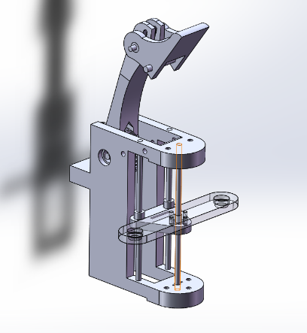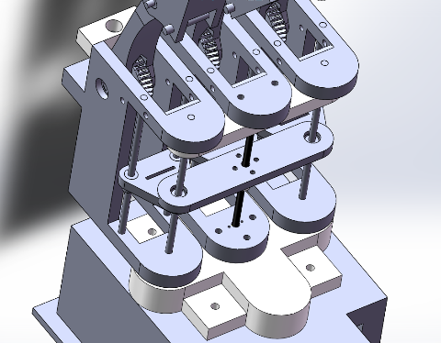
Fig 4.3 the 3D drawing of the middle finger, the 3D drawing of the connection part including the middle piece
As shown in the picture, the longboard attached to the piece is the connection. Its two ends, which have a hole in there, will attach to the other two-piece. In this design, the finger’s rotational center is in a line, which means the three fingers are in a line.
After designing the finger parts, a base is needed. The base part is the basic part of the hand. All three fingers are put together and then connected to the box. What’s more, all the electronic components except motors are placed inside or outside the box. On each side of the box, four holes can fit with the holes on the circuit board. There are also kerfs on the sides for data lines and wires to go through. The box is made up of two parts so it can be opened. The first part is the four sides and the top side. The second part is the bottom side. The two parts will be connected using screws and nuts after placing all the circuit boards and linking the wires.
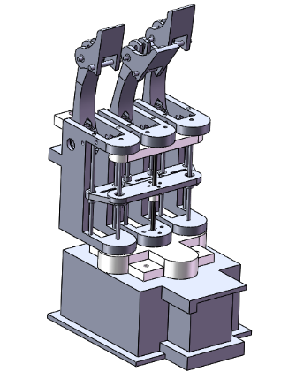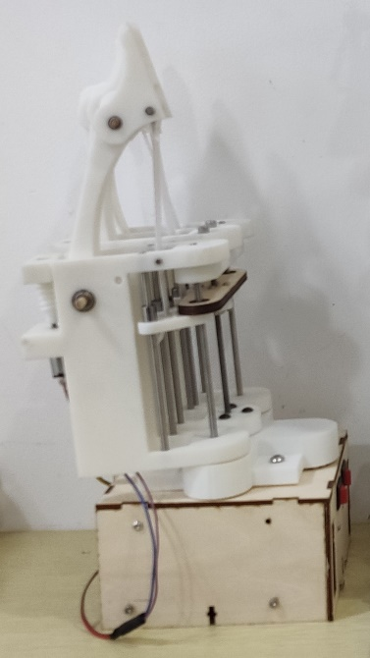
Fig 4.4 The picture of the first design(Left: The picture of the 3D drawing of the design; Right: The true product)
Below is a clear demonstration of the hand. Through the picture, we can see the whole structure and all the inner part. As shown in the figure, we can see the connecting board and the linear bearing.
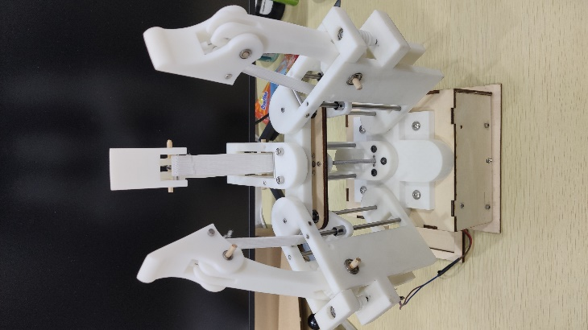
Fig 4.5 A close demonstration.

Electronics
In the first design, the circuit boards include an Arduino board (MEGA 2560, pictured on the right) and three L298N circuit boards (picture on the left). Each L298N board controls three motors.
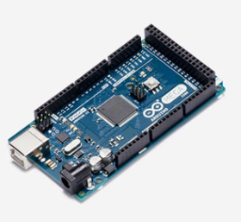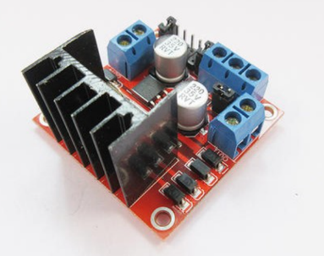
Fig 4.6 Arduino Mega 2560, L298N [17-18]
The Arduino board is the brain of the hand which runs the program. The reason for using MEGA 2560 is that MEGA 2560 has more ports than the UNO board. The L298N circuit board is a circuit board used to drive the motors. The maximum number of motors one L298N board can drive is two. This circuit board can control the speed of the motor and provides the right voltage input for the motors since the output voltage from the Arduino board is not enough (The maximum voltage output of the Arduino board is 5V, but the maximum voltage of the motor is 12V).
On the Arduino board, an extra Bluetooth module is added. This module is used for wireless control of the hand. The user can connect with the hand by Bluetooth through this module. This module also has four ports: GND, VCC, input port, and output port. In this design, all the port is connected.
For the actuators, the hand uses six motors. The model of the motor is a GM12-N20 gear motor. This motor has a reducer attached to it which can reduce the rotational speed of the motor yet increase the rotational torque of the motor. Thus, this type of motor has a very strong rotational force which can make sure the finger can grab the thing tightly. But at the same time a relatively slower speed to make sure the hand is controllable.

Test
After designing the first draft of the hand, I test the hand. It is a short test since I soon discover a lot of problems. In the experiment, I want the hand to grab different things such as a cola bottle, a hammer, my self-phone. The performance is underwhelming. For instance, the circle mode (detail will show in section 6) which has three fingers forming a circle is not a pretty circle. It is an oval. This makes the hand hard to grab round things. Another big experience is that I need to hold my hand by my arm each time I want to grab things. This way is not convenient since the robotic hand is big and heavy. Besides these two problems, there are also a lot of other small details that need to change. Therefore, I decided to make a new design and try to fix all the problems in this design. The problems and its solution will be shown in the latter paragraph.

Structural design

Actuation part design
In the original design, I decided to put the worm on the side as shown in figure 5.1. However, this causes the rotation of the finger to be limited. Therefore, I move the worm beneath the gear. This can make sure the finger can rotate to an angle bigger than 90 degrees.
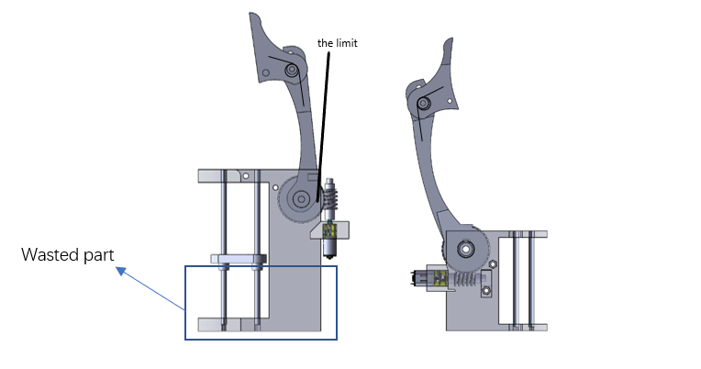
Fig 5.1 the 3D drawing of the finger part (left: first design, right: second design)
One detail is that there needs another force to pull the tip back since the belt can only pull the tip down. Therefore, there will be a torsional spring inside the tip to keep the tip balance. There will be a hole in the tip and a hole in the finger body. These two holes are used to keep the two legs of the torsional spring.

Outer shell design
This design also has several problems. The first revisable place is the length of it. As shown in Fig 5.1, there is a big wasted part in which there isn’t anything inside it. The only function of this area is to increase the total volume of the hand. Therefore, I cut this part in the new design. The second revisable part is the worm and gear part. Due to the reason that the worm will place beneath the gear, the fixation of the worm needs to be redesigned. The third problem is the rotation center for the side fingers. This will be explained in the next part in detail. The thing is that the rotation center will be changed which is not at the geometrical center of the shape but a special position decided through a model which will discuss in section 5.3. Therefore, the shape of the top surface needs to be redesigned.
Below is the picture of the 3D drawing of the new design.
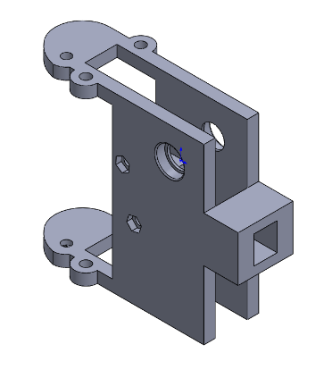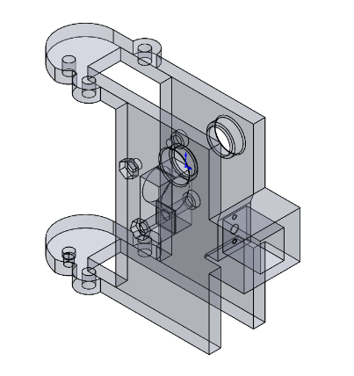
Fig 5.2 The 3D drawing of the new outer shell, the perspective figure of the 3D drawing
As shown in Fig 5.2, the outer shell is shorter and the extended structure hand has been modified to let the motor face inside where the worm will be. But several stop bolts are added. This is because the other tip of the worm also needs to be fixed and there needs to be a bearing on it to decrease the friction of the rotation. To make the assembly process easier, stop bolts are used. The structure is shown in fig 5.3.
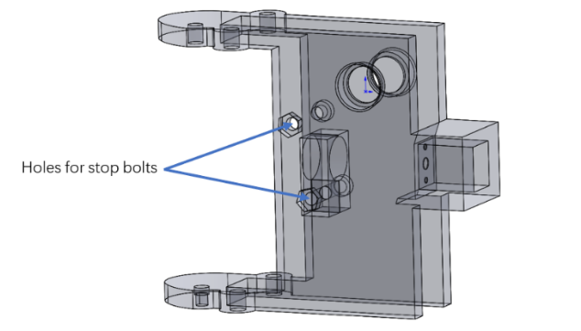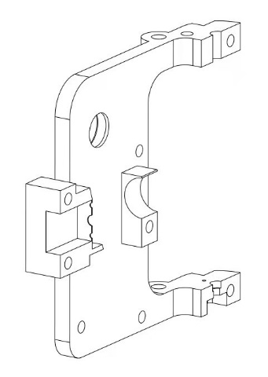
Fig 5.3 The perspective figure of the 3D drawing(left) and the section view(right)
As shown in the figure, this structure has two holes and a big clip inside it. The two holes are for stop bolts and the big hole on the clip is used to put the bearing.
The way this structure fixes the worm is through compression. When these two bolts which go through two sides of the shell are tightened, there will be a force pressing the two sides of the shell. Due to the flexibility of the 3D printing material, there will be a slight deform which pulls two sides together. This deform makes the big clip in the middle close and so clamp the bearing and the worm inside the bearing. In this way, it is easier for assembling since people can first put the worm and bearing together, then connect the worm with the motor. Finally, they can tighten the bolts and fix the worm.
A detail is that this time the outer shell is not a whole piece anymore. Instead, it is cut into half and then assemble, fixed through nuts.
The third big improvement made in the second design is to make the finger thinner. In the original design, the finger is too thick which makes the finger looks fat (before revising, the thickness of one finger is 40 mm, and the thickness of three fingers when they are in initial mode is 134 mm). This makes the hand very bloated.
To achieve the goal, I decrease the thickness in two ways. The first way is to straightly decrease the thickness of the shell and the other one is to decrease the thickness of the gap in the shell. The first way is simpler, straightly cutting the thickness is enough. But to achieve the second way is not easy. The thickness of the gap is dependent on the thickness of the finger body and the gear. In the first design, they are two parts connected through the axel. The thickness of the gear cannot be changed since it needs to fit with the worm. The only way is to decrease the thickness of the finger body which traps the gear. What if we just make the gear and the finger boy one part? This can eliminate the additional thickness brought by the finger body. Therefore, in the new design, I made the finger body and the gear one part as shown in Fig 5.4. As a result, the thickness of one finger is 24 mm and the thickness of three fingers when they are at initial mode is 92 mm.
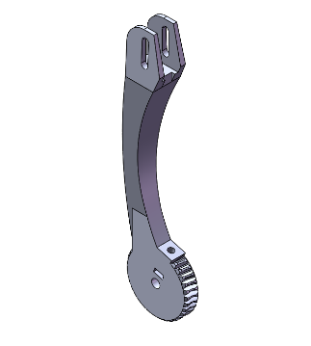
Fig 5.4 The new design of the finger’s main structure
The fourth improvement is to make the finger longer as shown in figure 5.1. In the original design, the finger is pretty short. This will limit the biggest size the hand can grab. This can be shown in the cola bottle experiment. The experiment is grabbing a big bottle (2L). Since the bottle is too big, the hand can hardly surround it and so fail to grab the bottle. Thus, the finger’s length is improved in the new design.

Finger position redesign
In the original design, the big board is a single “straight” board which means the rotational centers of the three fingers are in a line. This causes a serious problem. When the left and the right finger is at 120 degrees, it is not a circle between the three fingers but an oval as shown in figure 5.5
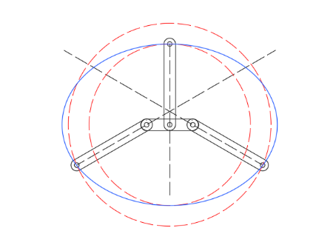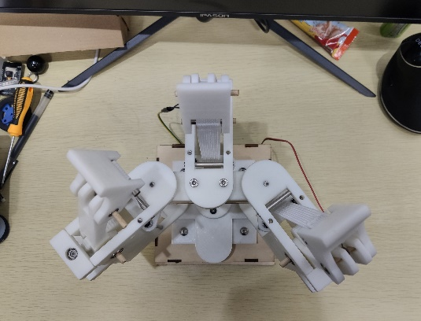
Fig 5.5 Explanation drawing and the picture of the original design
Hence, the shape of the big board is well calculated in the second design to make sure three fingers form a circle when they are transformed to Circle Mode. The calculation depends on the model built in a SOLIDWORK draft.
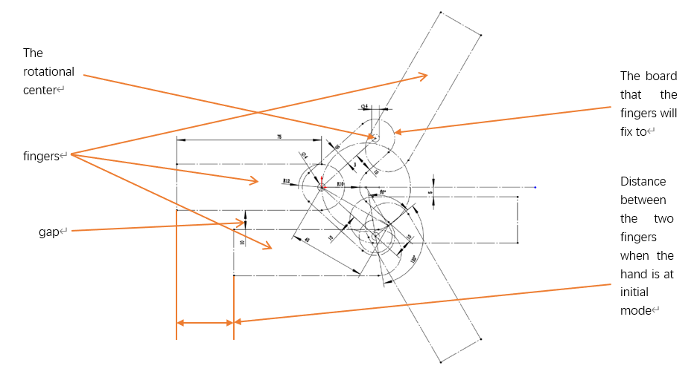
Fig 5.6 Rotational model.
In figure 5.6, all the numbers are annotated. The scale shown on the figure is the scale that would be the most fitful. This is because the gap should be smaller. However, the smaller the gap is, the bigger the distance between the end of the middle finger and the fingers on the two sides will be. Finally, the scale in the figure is chosen since it is quite balanced.
Due to the reason that the three fingers now is not in a line, the shape of the board connecting the three control piece of the belt should also be changed. It is not a straight board anymore, instead, it should be a special shape as shown in Fig 5.7 below.
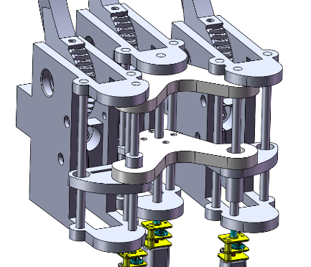
Fig 5.7 The design for the fingertip movement (second design)
After revising the problems, a new design is now set. Below is a whole view of the hand.
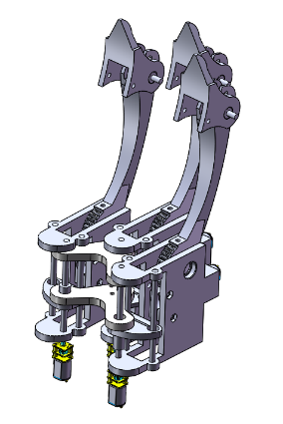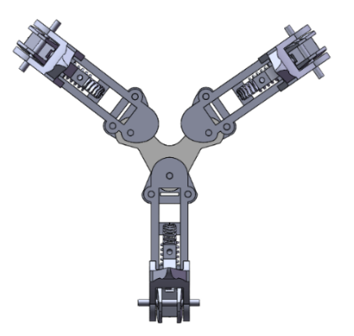
Fig 5.8 The 3D drawing of the upper part(without base), the 3D drawing of the hand when it’s under circle mode
Below is the picture of the circle mode of the true hand. We can see that the position of the three fingers are in a perfect circle shape.
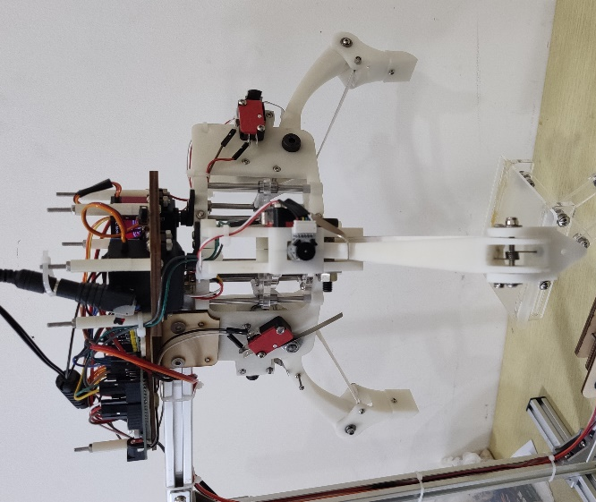
Fig 5.9 Circle mode

Base part design
However, this means that each time I want to use it, I need to hold it by my hand. Since the hand is pretty heavy, it is not very convenient. Therefore, I decided to put the hand on an outer structure made of profiles that hangs it and use a liftable platform to move the object I want it to grab. All the electronics like circuit board are moved to the top of the hand since the hand is now upside down in the new design.
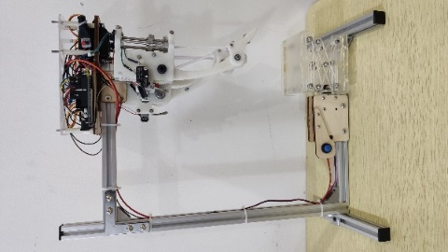
Fig 5.10 The new base part.
The outer structure used to hand the hand is made of metallic profiles as shown in Fig 5.10. At the top, it is connected to the hand and the electronic room. At the bottom, it is connected to the platform. Besides it, there are two wires connected between the electronic room and the platform. The connection between profiles is achieved through an angular-shaped metal and several screws and nuts.
The platform is using a putter as power and uses cross brackets as support. When the putter pushes out, the synergy structure will move up and so the platform will rise. Vice versa.
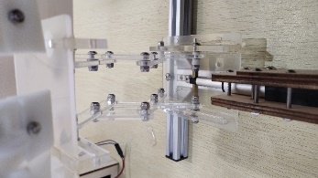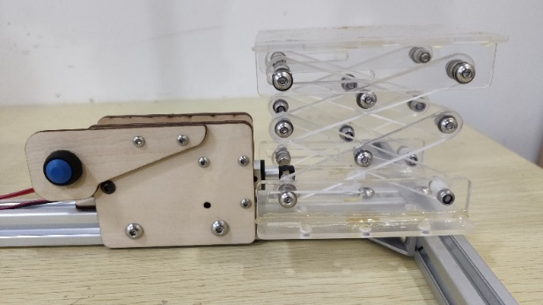
Fig 5.11 The platform

Material Attachments

3D printing
Most of the modules which are specially shaped are produced using 3D printing since it’s the most convenient way. The material used for 3D printing is resin since it is the most common material.

Wood board
The parts which have a board shape (thin) are made of boards. These parts are the middle longboard which is used to connect the three belts connecting part and the base part (the box). The box is made using wood board because the shape is regular so it is simple to assemble using wood boards.
In the new design, this part is illuminated which means there will be no wood boards. The reason is that the wood board makes the hand looks ugly and there the base had already changed into a movable platform and a big bracket so there is no necessity to use wood.

Metallic module
The axels in the part are made of metal since metal has a smooth surface so easier for sliders to move on it or parts to rotate. Another reason is that the axles are cylindrical which is a regular shape. There is no need to use 3D print. Besides these big parts, there are also some small pieces including the torsion spring and the bearing.

Electronics

Circuit boards
In the original design, the hand uses the Mega 2560 board due to reason that has more ports. However, later discover that a lot of ports are not used. So, MEGA 2560 is replaced as UNO board in the new design to save some volume. But the embarrassing thing is that the UNO board’s ports are not enough. Therefore, a java module is introduced which will be discussed in the next session.
Due to the reason that the two motors used to control the modes changing in the first design are changed into servers, there are only four motors in the new design. So, one L298N board is removed since only two are enough and the server doesn’t need an adapter.

Modules
There are two modules used in this hand: a java module and a Bluetooth module.
The Java module has an input of 12V and has four outputs which include GND, VCC 5V, and two connected signal outputs. The working concept of the module is shown in figure 7.1 below.
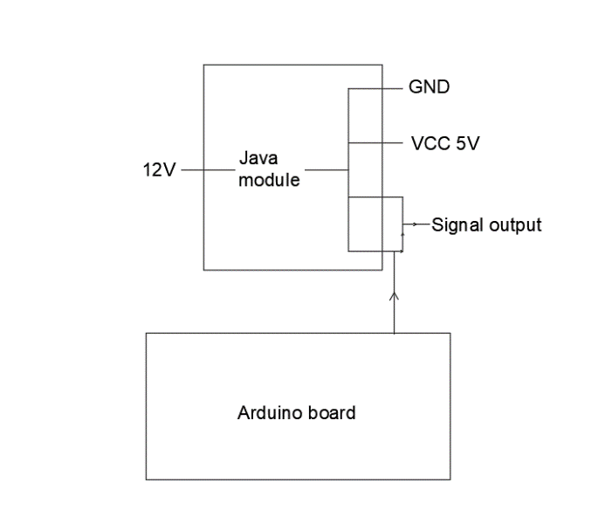
Fig 7.1 The working process of the java module
This module has a function of a hub. This hub can not only provide 5V power to the servers but also provides the same signals to both of the two servers with only one signal from the Arduino board which takes only one port.
To save ports, the Bluetooth module also makes some changes. In the first design, all of the four ports are connected to the Arduino board since there are enough ports. However, since this hand doesn’t necessarily need to report back to the controller, the output port of the module doesn’t need to be connected and there aren’t enough ports on the Arduino board in the new design, the output port of the Bluetooth module is left unused.

Motors and servers
In the new design, two of the motors are changed to servers. The model of the server is the DS3218 servo.

Switches
In the first design, there is only one switch that controls the battery supply for all the electronics. However, in the second design, four travel switches are added, three on the back of each of the fingers and one in front of the middle finger (one on each of the side fingers and two on the middle finger). These passive switches have three feet: one input foot and two output feet. When the switch is open which means nothing is pressing it, the input foot is connected with the default output foot. When it is pressed, the input foot will connect to the other foot. On this hand, we give a voltage input in the input foot and connect the not default foot to the Arduino board while the default foot is left unused. This structure will give the Arduino board a signal each time the switch is pressed. It functions like a press detector which can give the program an idea of where the finger is while also limiting the movement of the finger.
The reason why only the middle finger has a travel switch in front of it is that the middle finger needs to band automatically when transforming to two fingers mode. For the other two fingers, their banding is all controlled by the user so there is no need to limit their frontier range. Additionally, all the fingers need a limit on their back range (opening range) since all of them need to initialize automatically.
In the new design, there is also a new button added to control the power for the platform. This button is a push-button. When you press it, it will be locked at the bottom and the power is cut. When you press it again, it will open and the power is reconnected. This button can help the user manually control the platform. Since Bluetooth has been delayed, people can hardly raise the platform into the position they want if they only use wireless control. However, with this button, people can use Bluetooth to raise the platform and cut the power when the platform has reached its position.
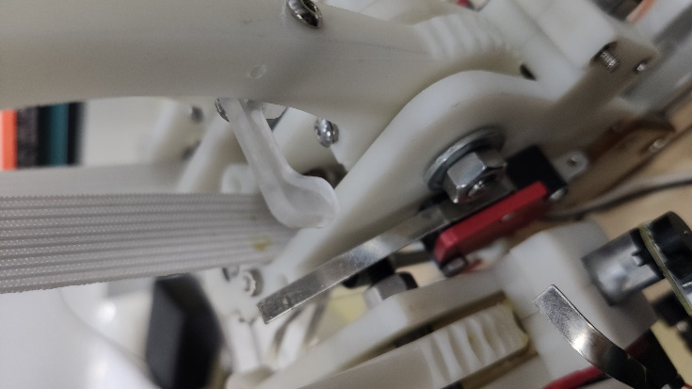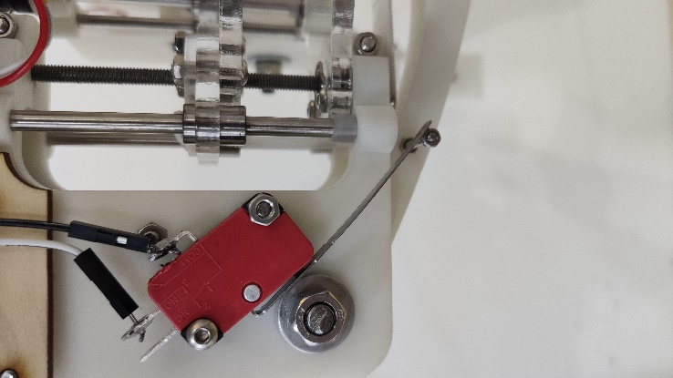
Fig 7.2 The travel switch (Left: the travel switch is not pressed; Right: the switch is pressed)

The Whole Electronic Part
Since the whole hand is hung up by the bracket, the electronic part cannot be put on the bottom of the hand. Therefore, all the circuit boards and wires are moved to the top, placed on the hand. The details of the whole part are shown in fig 7.2.
To protect the electronics, a square cover is added. There will be 7 pillars standing on the base and the cover can go on them to cover the top of all the electronics. Even though there isn’t any side protection, it is not necessary to protect it on the side since the hand now has a bracket and people don’t need to carry it everywhere anymore.
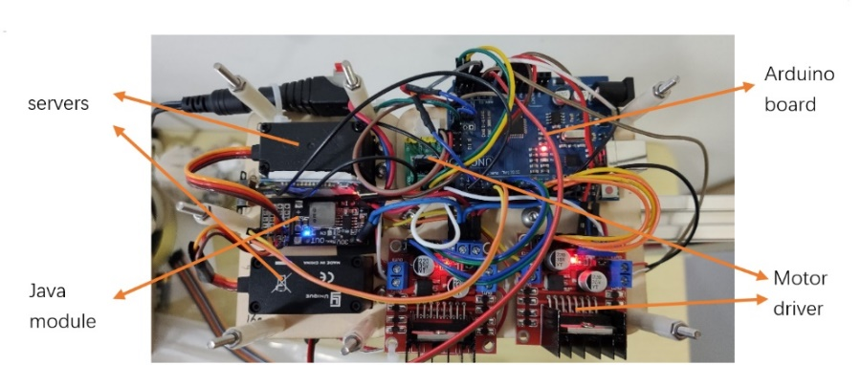
Fig 7.3 The Brain of the hand

Transforming modes
This hand has four modes which are initial mode, two-fingers mode, circle mode, and two-sides mode. The transformation of these four modes is controlled by the program.

Initial mode
This mode is the initial mode. The hand will start with this model. In this mode, all three fingers will be on the outset position of the hand, prepared for the program to transform it into other modes.
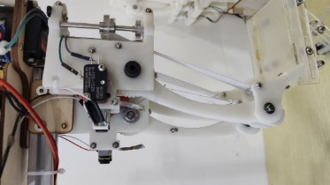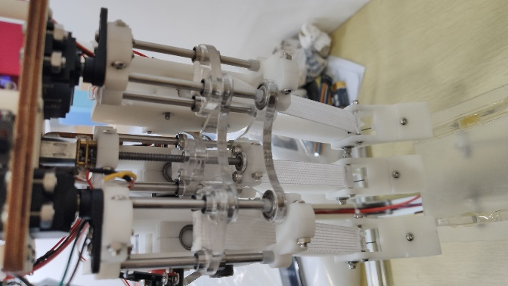
Fig 8.1 Initial mode

Two-fingers mode
This mode will have the middle finger banded down and the other two fingers will be on two opposite sides. In this case, the hand will use the fingertip of these two fingers to grab small things. You can consider it as a tweezer. When the hand wants to grip a screw, it can use this mode.
However, this mode has only two fingers working. The force the hand can act on the object is smaller compared to the circle mode and two sides mode. This means this model can only grab lighter things. If there are small heavy things, the two sides mode can be called.
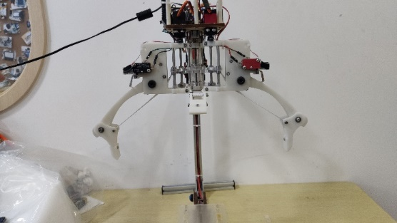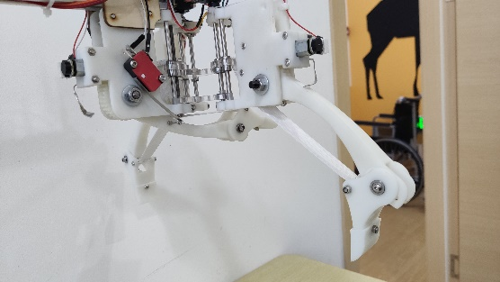
Fig 8.2 Two-fingers mode

Circle mode
This mode will have the three fingers in a circle shape with each having an angle of 120 degrees. This mode can grab things that have an outer shape similar to a circle. For instance, a cola bottle or a basketball.
Especially, when the fingers in this mode are band down to the maximum extent, when they touch each other, don’t transform into two fingers mode. This is because the middle finger needs to be banded down but it will be blocked by the other two fingers. If this situation happened, the middle finger may damage the other two fingers.
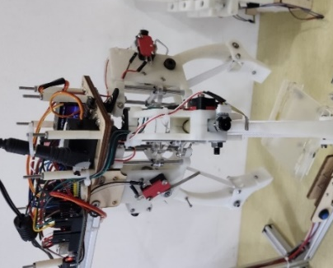
Fig 8.3 Circle mode

Two-sides mode
This mode will move the left and right fingers to their opposite so it will form another side that faces the middle finger. It functions like a bigger tweezer that can use its finger body to grab bigger things, especially cylinder-shaped things.
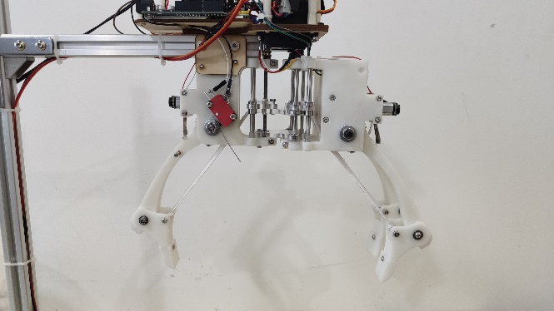
Fig 8.4 Two-sides mode

Programming and User Interface
The language used in this project is Arduino, and the compiler is IDE.

Functions it achieved
This program allows the user to control the robot through a blue tooth. It includes the function of transforming modes, controlling fingers’ movements in each mode and the platform, and protecting itself (self-protection mechanism).
The main part of the code controls the finger’s movement including the transformation and fingers of the mode and fingertips banding. The movement of the platform takes a small part and the self-protection mechanism is distributed separately in each method. These methods are the main blocks of the code which includes all the acts the hand can have.
Here are the interpretations of all the methods (all these methods are named in Chinese alphabetic):
jieshu(): Reset. End the act the hand has now and return the hand to the initial mode.
tingzhi(): Emergency stop. Stop the hand immediately.
zhuawo(): Grab. All the functional fingers in the current mode will begin to grab/
kaizhi(): Open. All the functional fingers in the current mode will open.
sanzhi(): Change to Circle mode.
duizhi(): Change to Two-sides mode.
erzhi(): Change to Two-fingers mode.
zhijianshou(): Tip grab. The tip of the functional fingers in the current mode will close.
zhijianfang(): Tip open. The tip of the functional fingers in the current mode will open.
pingtaisheng(): The platform moves upward.
pingtaijiang(): Platform move downward.
Especially, the travel switches added in the new design can help with the clarification of the location of fingers for the program as I mentioned before. In the codes, each method includes a detection part that can detect the specific travel switches it needs to help detect the code. Take jieshu() as an example. In that method, the program will keep detecting if the finger had already touched the travel switch at the end limit. If the finger doesn’t touch, then the program will keep the finger moving backward. If the finger does touch and responds to a signal to the program. The program will stop the movement of the finger and then move the finger forward for 5 seconds to make sure the finger is not at an extreme location. This way is efficient is because the program doesn’t know where the fingers are when the user press jieshu() and therefore the program cannot make sure how far should the fingers go back. What’s more, because of the small difference in the rotation speed of motors, the three fingers may stay at different places sometimes even though they should be in the same place. However, the program doesn’t need to consider the location of the fingers anymore in the new design with the help of travel switches.
Below is the logic map of the program:
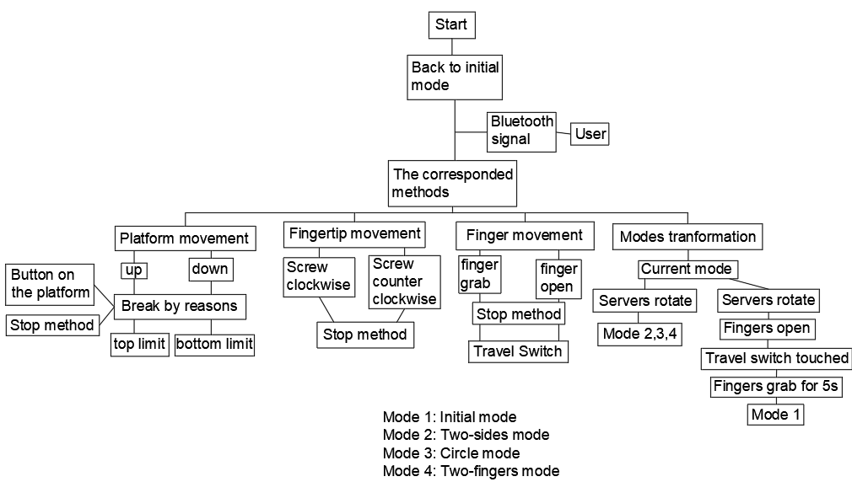
Fig 9.1 The working process of the whole program

The user interface:
The user can use the cellphone to control the hand. As shown in figure 9.2, the user interface has 10 buttons.
The first three buttons are modes transformation. Each button corresponds to a grasping mode. When these buttons are clicked down, the hand will transform to the mode it corresponds to.
The buttons on the second line control the movement of the finger. The “Stop” button will stop the finger. The “Grab” button will let the finger grab. The “Initial” button will initialize the finger. By initialize, I mean to move the finger’s position back to the open state but not change the grasping mode.
The four buttons on the bottom correspond to the platform and the tips. They control the movement of platforms and tips just like what their name is.
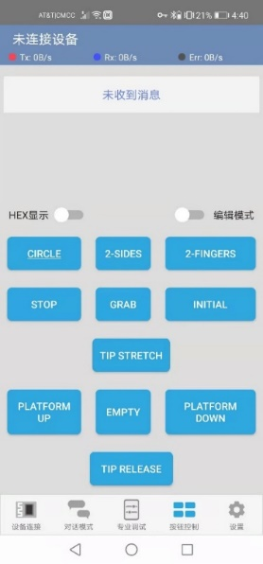
Fig 9.2 The screenshot of the control panel

Experiments (Second design)

Grabbing Ability experiments
These experiments test the hand’s grabbing ability. In the experiment, several different shaped objects are provided for the hand to grab. The hand can choose the mode which is most fitful the grabbing and it is counted as a failure if the hand fails in all five tries.
The environment is on a flat table. The hand is placed on the table and on the charge to prepare for the grabbing experiment. First, the object will be placed on the platform on the hand. Then the user will decide the grasping mode he will use and transform it into that mode. When he is ready, he can begin to lift the platform to a proper height. Then the user can begin to grab the object. If the hand can successfully grab the object, lower the platform to see if the hand can hold the object. If the hand can hold it, then the grabbing will be counted as a success. Otherwise, the grabbing will be counted as a failure. But no matter what the result is, this process will be repeated three times. If two or more times can succeed, the testing result will be a success. Otherwise, fail.
The objects provided are all daily stuff. They have a size range from big as a soccer ball to small as a screw to test if the hand can handle them. The results are shown in the form below.
Objects | weight/g | shape | Grasping modes | Tip shape | Testing result
Soccer ball | 407.4 | Sphere | Circle mode | Flat | Success
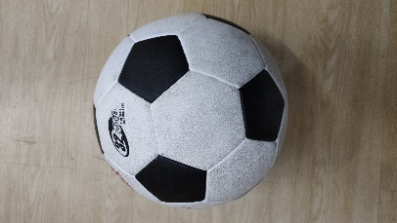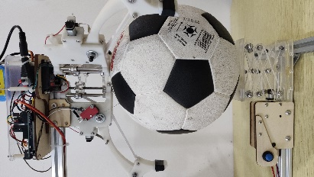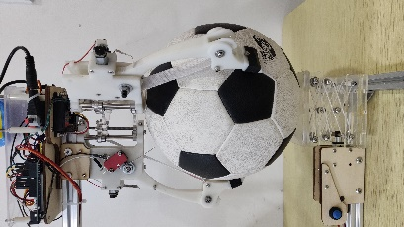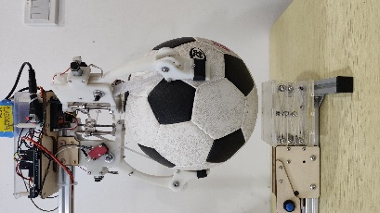
Plastic Wheel | 35 | Flat Cylinder | Circle mode | Flat | Success
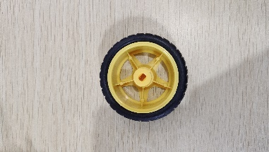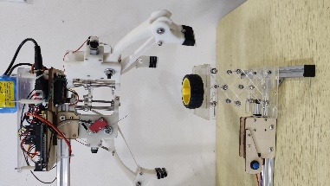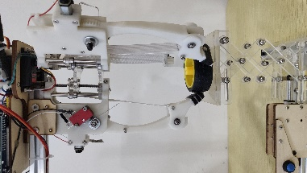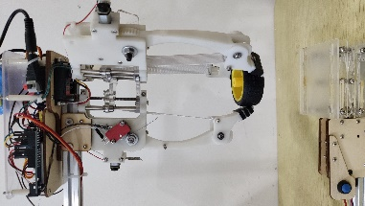
Plastic tape | 113.5 | Cylinder | Circle mode | Flat | Success
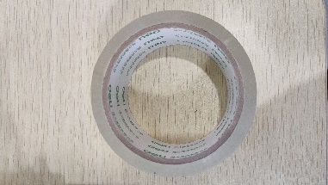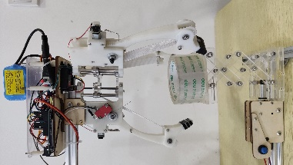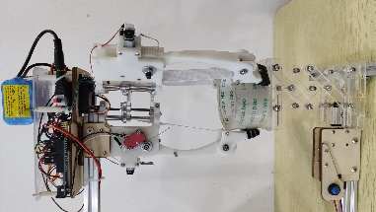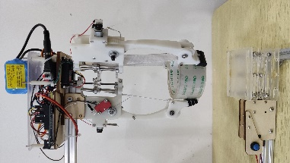
Battery | 47.8 | cuboid | Two fingers/sides | Flat | Success
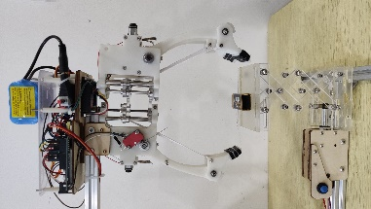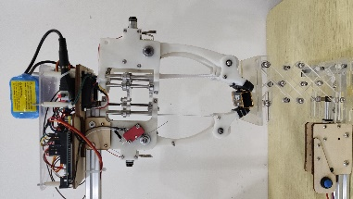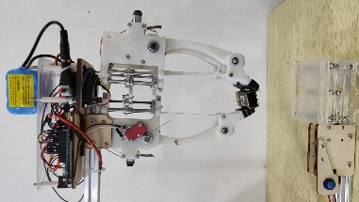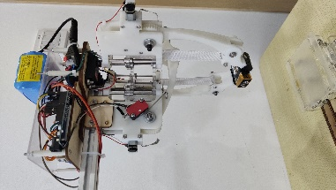
A bottle of water | 365.4 | Cylinder | Circle mode | Flat | Success
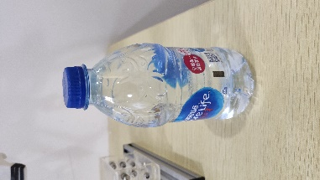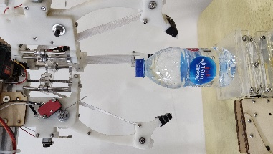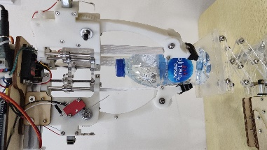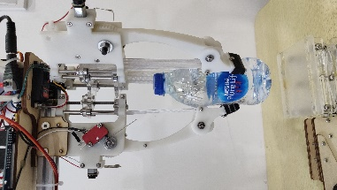
Needle nose pliers | 153.1 | Unregular | Circle mode | Flat | Success
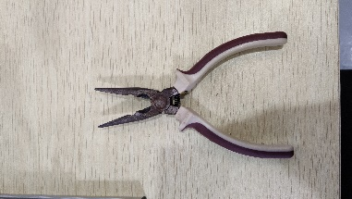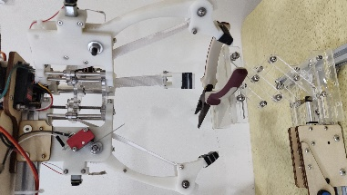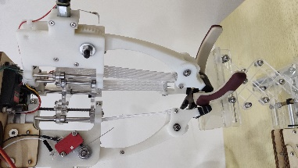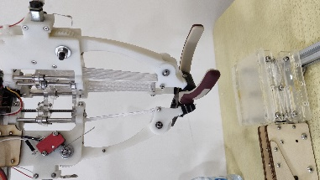
Cell phone | 216.3 | Flat cuboid | Two sides mode | Flat | Success
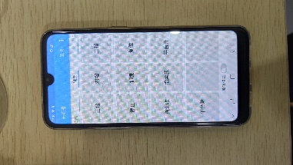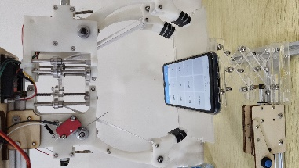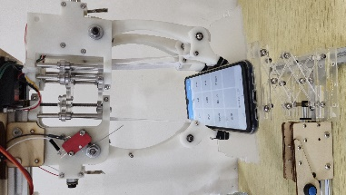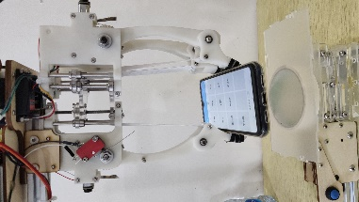
Finger Tip | 5.5 | Unregular | Two sides mode | triangular | Success
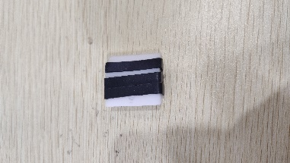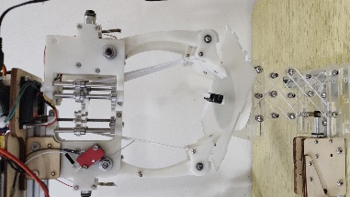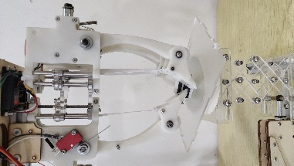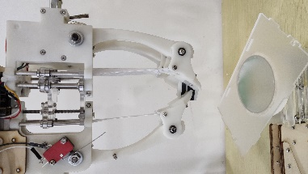
Nut | 2.2 | Hexagonal prism | Two fingers mode | Flat | Success
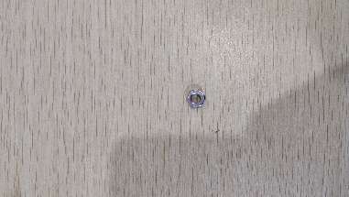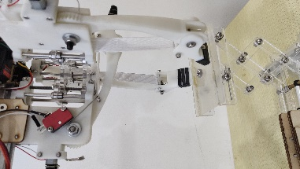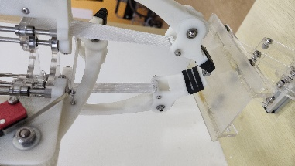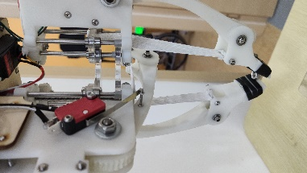
Pen | 8.6 | Long Cylinder | Two fingers mode | Flat | Success
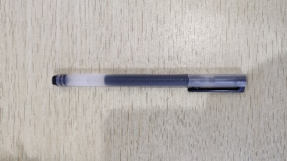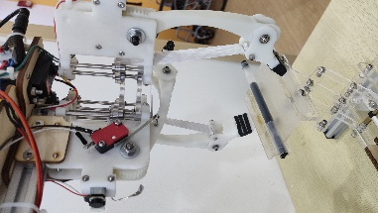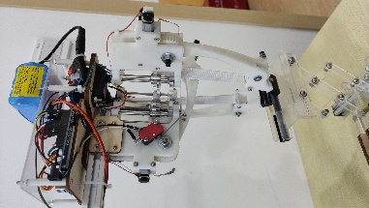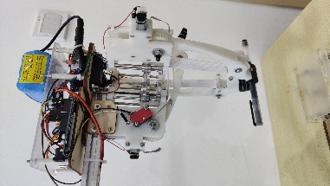
Screw | 3.9 | Small Cylinder | Two fingers mode | Flat | Success
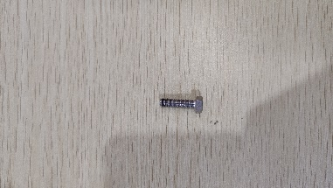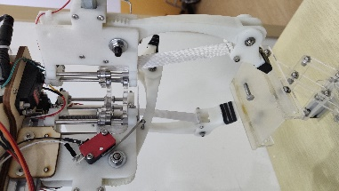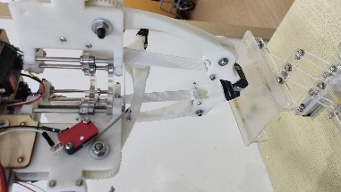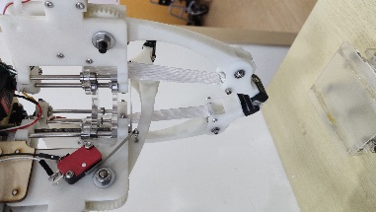
Empty jar | 24.9 | Cylinder | Two fingers mode | Flat | Success
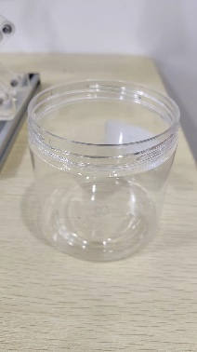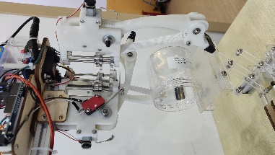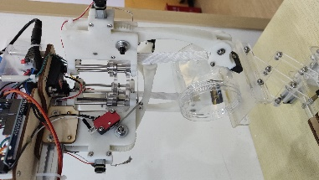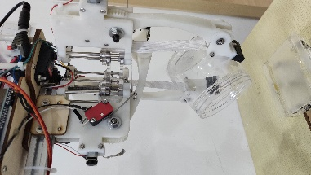
The results show that this hand has a strong grabbing ability. It can grab a lot of different-sized objects in daily life.

Ultimate Grabbing Experiments
This experiment focuses on finding the maximum grabbing force of the hand.
In the experiment, the object is the Cylindrical empty jar since it is the most fitful shape for the hand. After each turn, there will be counterweights added to the jar until the hand cannot hold the jar on all five tries. Count the weight at this time as the maximum weight. The result is shown below.
Grasping mode | Tip Shape | Maximum weight/g
Circle mode | Flat | 428.3
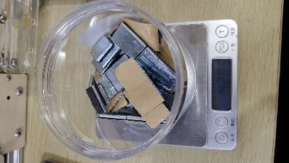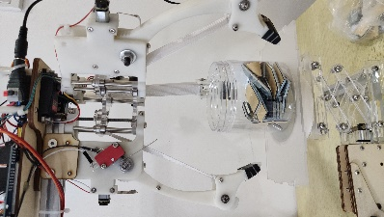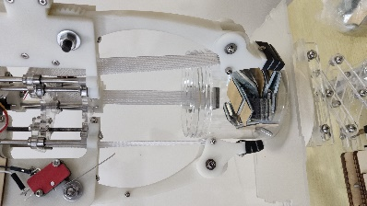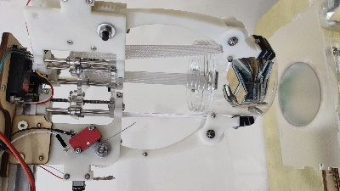
Two sides mode | Flat | 404.1
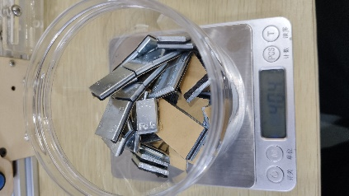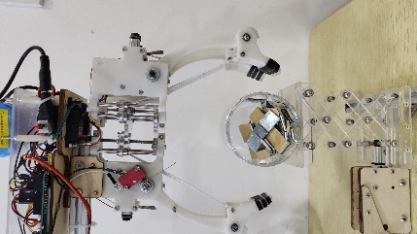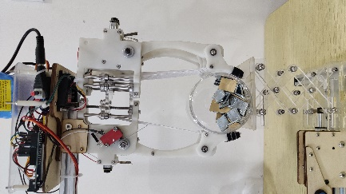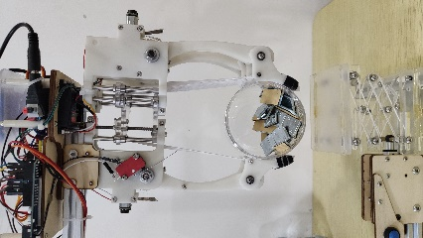
Two fingers mode | Flat | 272.5
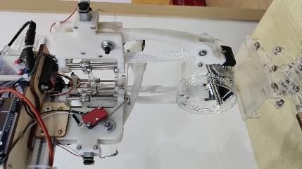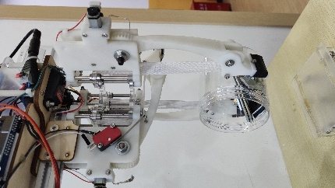
In the experiment for two sides mode and two fingers mode, the jar is placed horizontally. This is because these two modes can have the fingers surround the jar when it lies down which can have a stronger grabbing.
Since the two sides mode has three fingers working while the two fingers mode only has two, the weight two sides mode can lift is bigger than the two fingers mode.
In the experiment for circle mode, the material of the jar causes the weight circle mode can grab to be only 24 grams bigger than the two sides mode. The jar is made of plastic which will deform when the hand is an acting force on it. This causes the contact surface to be not flat and so decreases the friction force. What’s more, the end of the tip has the biggest force act on since that part is closest to the rotational center. The problem is that the elastic band is connected from the end of the tip and the elastic band has a smaller fraction coefficient (smoother) than the tip module. Hence, the result is only 24 grams higher than the two sides’ mode.

Conclusion
This paper presents a three-finger 4 modes robotic hand that has active transition capability between the precise parallel pinch and compliant grasp. The elastic band mechanism provides the hand with the self-adaptive ability to the object which is similar to soft robots which allow the hand to grab most items of arbitrary size. The self-locked mechanism can help the hand to grab the object tightly but also decrease the abrasion of components like the gear. At the same time, the structure and the mechanism of this hand are relatively simple. There are a total of five motors and one server. This is the smallest number of actuators to achieve the goal of this hand. The control concept and strategy of the transition of grasping modes and the grab is simple and easy to understand.
In the future, robust and reliable joint torque sensors and fingertip force sensors will be developed. In this project, there is no way to detect the force of the hand acting on the object and so cannot make sure the hand will not damage the object. A force sensor and a torque sensor can help to solve this problem.

References
[1] Chapman Jayden, A Locally-Adaptive, Parallel-Jaw Gripper with Clamping and Rolling Capable, Soft Fingertips for Fine Manipulation of Flexible Flat Cables, IEEE International Conference on Robotics and Automation (ICRA) DOI: 10.1109/ICRA48506.2021.9561970
[2] M. Guarnieri, I. Takao, E. F. Fukushima, and S. Hirose, "HELIOS VIII search and rescue robot: Design of an adaptive gripper and system improvements," 2007 IEEE/RSJ International Conference on Intelligent Robots and Systems, 2007, pp. 1775-1780, DOI: 10.1109/IROS.2007.4399372.
[3] Blanes Carlos, M. Martin, B. Pablo, “Tactile sensing with accelerometers in prehensile grippers for robots”, Elsevier Ltd, DOI:10.1016/j.mechatronics.2015.11.007, 2015.
[4] M. Cutkosky, “On grasp choice, grasp models, and the design of hands for manufacturing tasks,” IEEE Trans. on Robotics and Automation, Vol. 5, No. 3, pp. 269–279, 1989.
[5] T. Feix, et al., “The grasp taxonomy of human grasp types,” IEEE Trans. on Human-Machine Systems, Vol. 46, No. 1, pp. 66–77. 2016
[6] Mo A, Zhang W Z. A universal robot gripper based on concentric arrays of rotating pins. Sci China Inf Sci, 2019, 62(5): 050214, https://doi.org/10.1007/s11432-018-9716-2
[7] T. Laliberte, et al., “Underactuation in robotic grasping hands,” Machine Intelligence & Robotic Control, vol. 4, no. 3, pp. 1-11, 2002.
[8] L. Kang, J. -T. Seo, D. Yoon, S. -H. Kim, I. H. Suh and B. -J. Yi, "Design of a 3-DOF Linkage-Driven Underactuated Finger for Multiple Grasping," 2019 IEEE/RSJ International Conference on Intelligent Robots and Systems (IROS), 2019, pp. 5608-5613, DOI: 10.1109/IROS40897.2019.8968037.
[9] M. V. Liarokapis and A. M. Dollar, "Learning task-specific models for dexterous, in-hand manipulation with simple, adaptive robot hands," 2016 IEEE/RSJ International Conference on Intelligent Robots and Systems (IROS), 2016, pp. 2534-2541, DOI: 10.1109/IROS.2016.7759394.
[10] Y. -J. Kim, Y. -J. Jeong, H. -S. Jeon, D. -W. Lee and J. -I. Kim, "Development of a soft robotic glove with high gripping force using force distributing compliant structures," 2017 IEEE/RSJ International Conference on Intelligent Robots and Systems (IROS), 2017, pp. 3883-3890, DOI: 10.1109/IROS.2017.8206240.
[11] J. H. Low et al., "A compliant modular robotic hand with fabric force sensor for multiple versatile grasping modes," 2016 6th IEEE International Conference on Biomedical Robotics and Biomechatronics (BioRob), 2016, pp. 1230-1235, DOI: 10.1109/BIOROB.2016.7523799.
[12] T. Nishimura, K. Mizushima, Y. Suzuki, T. Tsuji, and T. Watanabe, "Variable-Grasping-Mode Underactuated Soft Gripper With Environmental Contact-Based Operation," in IEEE Robotics and Automation Letters, vol. 2, no. 2, pp. 1164-1171, April 2017, DOI: 10.1109/LRA.2017.2662086.
[13] G. P. Kontoudis, M. Liarokapis and K. G. Vamvoudakis, "An Adaptive, Humanlike Robot Hand with Selective Interdigitation: Towards Robust Grasping and Dexterous, In-Hand Manipulation," 2019 IEEE-RAS 19th International Conference on Humanoid Robots (Humanoids), 2019, pp. 251-258, DOI: 10.1109/Humanoids43949.2019.9035037.
[14] Hermann Katharina,” A Joint-Selective Robotic Gripper with Actuation Mode Switching” IEEE Trans. International Conference on Automation Science and Engineering Vol. 19, pp. 1532-1539 2019
[15] Zhou Jianshu, “A Soft-Robotic Gripper With Enhanced Object Adaptation and Grasping Reliability” IEEE Robotics and Automation Letters, Vol. 2, No. 4, pp. 2287-2293, October 2017
[16] María F. Mogro. Dario J. Mendoza, Angel M. López, “Adaptive Gripper Controlled with Linear Micro Actuator for Correct Fastening of Objects of Variant Forms” International Journal of Mechanical Engineering and Robotics Research Vol. 9, No. 4, April 2020.
[17] Mega 2560: https://www.electronicscomp.com/arduino-mega-2560-r3-india
[18] L298N: https://zhuanlan.zhihu.com/p/71615775?utm_source=qq
[19] J. Morrow, A. Kothari, Y. H. Ong, N. Harlan, R. Balasubramanian, and C. Grimm, "Using human studies to analyze capabilities of underactuated and compliant hands in manipulation tasks," 2018 IEEE/RSJ International Conference on Intelligent Robots and Systems (IROS), 2018, pp. 2949-2954, DOI: 10.1109/IROS.2018.8594344.
[20] A. Kakogawa, H. Nishimura and S. Ma, "Underactuated modular finger with pull-in mechanism for a robotic gripper," 2016 IEEE International Conference on Robotics and Biomimetics (ROBIO), 2016, pp. 556-561, DOI: 10.1109/ROBIO.2016.7866381.
[21] C. B. Teeple, G. R. Kim, M. A. Graule and R. J. Wood, "An Active Palm Enhances Dexterity of Soft Robotic In-Hand Manipulation," 2021 IEEE International Conference on Robotics and Automation (ICRA), 2021, pp. 11790-11796, DOI: 10.1109/ICRA48506.2021.9562049.
[22] K. Morino, S. Kikuchi, S. Chikagawa, M. Izumi and T. Watanabe, "Sheet-Based Gripper Featuring Passive Pull-In Functionality for Bin Picking and for Picking Up Thin Flexible Objects," in IEEE Robotics and Automation Letters, vol. 5, no. 2, pp. 2007-2014, April 2020, DOI: 10.1109/LRA.2020.2970630.
[23] K. Sasaki, K. Koyama, A. Ming, M. Shimojo, R. Plateaux, and J. Choley, "Robotic Grasping Using Proximity Sensors for Detecting both Target Object and Support Surface," 2018 IEEE/RSJ International Conference on Intelligent Robots and Systems (IROS), 2018, pp. 2925-2932, DOI: 10.1109/IROS.2018.8594430.
[24] A. T. Mathew, I. Hussain, C. Stefanini, I. M. Ben Hmida, and F. Renda, "ReSoft Gripper: A reconfigurable soft gripper with monolithic fingers and differential mechanism for versatile and delicate grasping," 2021 IEEE 4th International Conference on Soft Robotics (RoboSoft), 2021, pp. 372-378, DOI: 10.1109/RoboSoft51838.2021.9479341.
[25] H. Liu, L. Zhao, B. Siciliano, and F. Ficuciello, "Modeling, Optimization, and Experimentation of the ParaGripper for In-Hand Manipulation Without Parasitic Rotation," in IEEE Robotics and Automation Letters, vol. 5, no. 2, pp. 3011-3018, April 2020, DOI: 10.1109/LRA.2020.2974419.
[26] C. Liu, G. Huang, C. Chiu, and T. Chen, "Topology and size optimization of an adaptive compliant gripper to maximize the geometric advantage," 2016 IEEE International Conference on Advanced Intelligent Mechatronics (AIM), 2016, pp. 1145-1150, DOI: 10.1109/AIM.2016.7576924.
[27] S Kaviyarasan and I Infanta Mary Priya 2018 IOP Conf. Ser.: Mater. Sci. Eng. 402 012043
[28] J. Chapman et al., "A Locally-Adaptive, Parallel-Jaw Gripper with Clamping and Rolling Capable, Soft Fingertips for Fine Manipulation of Flexible Flat Cables," 2021 IEEE International Conference on Robotics and Automation (ICRA), 2021, pp. 6941-6947, DOI: 10.1109/ICRA48506.2021.9561970.”
[29] M. Guarnieri, I. Takao, E. F. Fukushima, and S. Hirose, "HELIOS VIII search and rescue robot: Design of an adaptive gripper and system improvements," 2007 IEEE/RSJ International Conference on Intelligent Robots and Systems, 2007, pp. 1775-1780, DOI: 10.1109/IROS.2007.4399372.
[30] N. Elangovan, A. Dwivedi, L. Gerez, C. Chang and M. Liarokapis, "Employing IMU and ArUco Marker Based Tracking to Decode the Contact Forces Exerted by Adaptive Hands," 2019 IEEE-RAS 19th International Conference on Humanoid Robots (Humanoids), 2019, pp. 525-530, DOI: 10.1109/Humanoids43949.2019.9035051.
[31] W. G. Bircher and A. M. Dollar, "Design Principles and Optimization of a Planar Underactuated Hand for Caging Grasps," 2019 International Conference on Robotics and Automation (ICRA), 2019, pp. 1608-1613, DOI: 10.1109/ICRA.2019.8793465.

